Evidence-Aware Pre-Payment Risk Assessment for UPI Transactions Using Payer Behaviour, Payee History, and an Incremental Payment Graph
Chinthada Murali Naga Raju, Chigurupati Vanya Kishore, Gudivada Yaswanth Naga Duga Prabhas, Bethapudi Vivek, and K. Kishore Raju
Department of Information Technology, Sagi Rama Krishnam Raju Engineering College (A), Bhimavaram, Andhra Pradesh, India (affiliated to Jawaharlal Nehru Technological University, Kakinada)
Abstract—In instant payment systems such as India’s Unified Payments Interface (UPI), transfers settle within seconds. The opportunity to prevent loss therefore lies before submission, especially for payer-authorised deception, in which the legitimate account holder is persuaded to pay a fraudster and the payer’s own behaviour carries little signal. This paper proposes an advisory pre-payment risk-assessment architecture that combines ten evidence families. They cover payer behaviour, observed payee history, an incremental payer–payee graph, payment-address and QR analysis, amount, message, link and stated-purpose context, and a calibrated gradient-boosting classifier. Each family declares its availability and the typed facts it relies on. Risk is therefore reported separately from evidence coverage, and corroboration is credited only across distinct observations. Because labelled UPI fraud data are not public, the classifier is evaluated on a synthetic corpus of 120,000 payments from 2,000 payers with a fraud prevalence of 1.183%. The running prototype retains a 12-feature model (V1), which reaches a PR-AUC of 0.4860 on the held-out test split. An expanded 47-feature research representation (V2), frozen and evaluated offline, reaches a PR-AUC of 0.7326, a ROC-AUC of 0.9900, a recall of 0.7803 at a false-positive rate of 0.00995 and a Brier score of 0.00555; its social-engineering recall is 65.93%, versus 19.23% for V1. The V2 graph, message, link and purpose channels are generated by the same simulator. The results therefore characterise the classifier under controlled synthetic conditions rather than real-world UPI performance, and the complete ten-family verdict system was not benchmarked end to end.
Index Terms—Authorised push payment fraud, evidence aggregation, explainable machine learning, fraud risk assessment, pre-payment assessment, probability calibration, transaction graph, Unified Payments Interface (UPI).

I. Introduction

A. Background and Motivation
Retail payments in India have moved rapidly toward the Unified Payments Interface (UPI), an interoperable real-time payment system in which a payer addresses a recipient through a virtual payment address (VPA), a mobile number or a QR code, and funds move between bank accounts within seconds [1]. Immediacy, low friction and availability at any hour make such systems attractive, but they also change the economics of fraud. When a transfer settles almost instantly and is difficult to reverse, the opportunity to prevent loss lies between the payer’s decision to pay and the submission of the payment. Detection after settlement supports investigation and recovery, but it cannot restore funds that have already been moved onward.
Payment fraud detection has long been treated as statistical classification over transaction records, in which a transaction is compared with the history of the account that made it [2]. Operational studies show that the problem departs from textbook classification: fraud is rare, labels arrive late, patterns drift, and investigators can review only a limited number of alerts [3]. Instant payments add a further constraint. The relevant decision is no longer whether a completed transaction was fraudulent, but whether a payment that has not yet been made should proceed, proceed with a warning, or be verified first.

B. Problem Context
Two broad forms of payment fraud can be distinguished. In the first, an attacker gains control of an account or credential and initiates payments that the owner did not authorise. In the second, the owner initiates and authenticates the payment personally after being deceived — for example, by an impersonated official, a fraudulent seller, a fake refund process or a message that manufactures urgency. This second form, commonly called authorised push payment (APP) fraud, has attracted regulatory attention because the victim’s own authentication makes the payment appear legitimate [4].
The distinction matters for detection design. Behavioural anomaly detection assumes that fraud leaves a trace in the payer’s activity. When a deceived payer pays at a familiar hour, from a familiar device and for an ordinary amount, payer-side features may look normal. The more informative observations then concern who is being paid, how that recipient has been paid by others, the address or QR code that identifies it, and the message that prompted the payment. Graph-based methods exploit such relational structure [5], [6], and recent work stresses that transaction graphs evolve continuously, which favours incremental maintenance [5] and temporal modelling [7]. Combining heterogeneous evidence raises two further difficulties. First, substituting default values for unavailable measurements can silently turn “unknown” into a specific and possibly misleading input. Second, rewarding several components for observing the same fact overstates the strength of the evidence.

C. Research Gap
Much of the transaction-level literature evaluates classifiers on completed records and emphasises deviations in payer behaviour [2], [3]. Graph-based approaches are usually formulated as detectors over the whole graph — identifying dense collusive groups [5], [6] or learning node representations [7] — rather than as a source of evidence for a single payment that has not yet been made. The UPI-specific study reviewed here applies an XGBoost classifier with SMOTE oversampling to transaction features and reports accuracy [8]. In the works reviewed for this study (Table I), contextual signals such as address integrity, QR consistency, message coercion and link reputation are rarely combined with payer and payee evidence in one assessment. Those works also do not generally describe how unavailable evidence is represented, or how correlated signals are kept from counting as independent corroboration.

D. Proposed Approach and Scope
This study proposes an evidence-aware pre-payment risk-assessment architecture for UPI-style payments. It is an advisory decision-support layer that assesses a payment request, identified by a scanned QR payload, a VPA or a mobile number, before submission. It is not a payment processor, bank, payment service provider (PSP) or part of the national switching infrastructure. It does not execute, hold or settle payments, and it is not integrated with the National Payments Corporation of India (NPCI) or with any bank or PSP.
For each request, ten evidence families report a score, whether they could observe anything, and the underlying facts on which the score rests. An aggregation rule lets the strongest signal lead, lets further signals contribute with diminishing weight, and grants a corroboration bonus only for agreement across distinct facts. The output is a risk score, a separate coverage (evidence-confidence) score, one of four advisory verdicts, and human-readable findings.
Two classifier representations are reported and kept distinct throughout (Section VI-D). The running prototype retains V1, a compact 12-feature baseline. V2 is an expanded 47-feature research representation that was frozen and evaluated offline. V2 provides the primary predictive result but is not deployed. The predictive experiments evaluate the classifier component on synthetic data; the incremental graph and the aggregation logic are validated separately by software tests; and the complete ten-family verdict system is not benchmarked end to end.

E. Contributions
The contributions of this study are positioned around the pre-payment setting, the treatment of evidence and the integration of established techniques, rather than around any single new learning algorithm:
- An integrated pre-payment architecture that combines payer behavioural evidence with payee history, payer–payee relational evidence, and context from the payment address, QR payload, amount, message, links and stated purpose, for a payment that has not yet been submitted.
- An evidence-aware aggregation mechanism in which each family declares its availability and typed facts. The mechanism reports risk separately from coverage, assigns no rule-based score to unavailable families, and limits double counting when families rest on one observation.
- An incrementally maintained payer–payee graph that supplies explicit, interpretable relational quantities to the live assessment path without per-request rebuilding.
- A reproducible, imbalance-aware evaluation that compares the running V1 baseline with the offline V2 representation, with validation-only model selection and a single held-out test measurement, complemented by software validation of the graph and aggregation logic.

F. Paper Organization
Section II reviews related work. Section III formulates the problem, and Section IV describes the architecture, which Section V formalises. Section VI covers data construction and feature engineering, Section VII the fraud-risk models, and Section VIII evidence aggregation and explainability. Section IX sets out the experimental methodology and Section X the results. Section XI discusses the findings, Section XII the threats to validity, and Section XIII concludes.

II. Related Work

A. Behavioural and Transaction-Level Fraud Detection
Statistical treatments of fraud detection established the problem’s defining characteristics: fraud is a small minority, missed fraud and false alarms carry very different costs, and fraudsters adapt to deployed controls [2]. Behavioural detection characterises what is normal for an account — typical amounts, hours, frequency and counterparties — and scores new transactions by their deviation from it. Velocity measures capture the bursts typical of card testing and account draining, and amount ratios capture unusually large transfers. Studies of operational card data show that realistic evaluation must account for limited investigation capacity, delayed labels and concept drift [3]. Such features work well when fraud changes the account’s observable behaviour, as in account takeover, and weaken when a deceived payer behaves normally.

B. Graph-Based Fraud Detection
Graph-based methods make relational patterns explicit. One line of work detects fraud as unusually dense subgraphs; FRAUDAR, for example, bounds the effect of camouflage edges that fraudsters add to legitimate nodes [6]. Graph neural networks (GNNs) instead learn node representations by aggregating information from neighbours. CARE-GNN counters camouflage by learning which neighbours to aggregate [9], and graph convolutional networks have been used to classify illicit flows in cryptocurrency transaction graphs [10]. Wang et al. go further than binary node labelling with an adaptive prototype-based GNN (APGNN). APGNN learns several prototypes, each representing a distinct behaviour pattern within a class, and projects nodes onto them. It reports improved detection and more interpretable results on four real-world datasets [11]. This fine-grained view of user behaviour is related in spirit to the present work’s interest in explaining why a payment looks unusual, but APGNN learns its behaviour patterns from graph structure. The present system, by contrast, states its evidence explicitly as named findings. It performs neither dense-subgraph mining nor graph representation learning, reading instead a small set of explicit quantities from a maintained payer–payee graph as one evidence family among several.

C. Dynamic and Temporal Transaction Graphs
Payment graphs change as transactions arrive. Spade+ addresses this for dense-subgraph detection in an industrial deployment: it maintains the peeling order on which dense-subgraph algorithms depend under both edge insertions and deletions, and it lets developers define their own suspiciousness functions [5]. PGLTSE treats time as information to be learned. It models transactions as a continuous-time dynamic graph and combines entity-level and transaction-relation-level graph learning with gang-aware risk propagation to detect organised fraud [7]. The present study shares the motivation for incremental maintenance and temporal awareness but reproduces neither method. Its graph is updated in the same storage transaction that records a payment, and the assessment path reads the maintained quantities without rebuilding the graph. The resulting features feed a classical calibrated classifier and a rule-based evidence aggregator.

D. UPI and Authorized Push Payment Fraud
Research on UPI has examined its role in digital payments and financial inclusion [1]. APP fraud has been studied mainly from legal and regulatory perspectives, including how losses should be allocated between customers and providers [4]. Its defining feature for detection is that the legitimate owner authenticates the payment, so identity-verification controls offer no protection when that person has been manipulated. Peer-reviewed work on UPI fraud detection remains limited. Rani et al. combine SMOTE oversampling, principal component analysis and an XGBoost classifier with a monitoring interface, and compare algorithms by accuracy [8]. Under a low fraud rate, accuracy can remain high even for a classifier that misses most fraud, so those figures are not comparable with the precision–recall measures used here.

E. Evaluation Under Class Imbalance
When negatives vastly outnumber positives, a small false-positive rate can still yield many false alarms per true detection. Saito and Rehmsmeier showed empirically that precision–recall plots are more informative than receiver operating characteristic (ROC) plots on imbalanced data [12]. Davis and Goadrich analysed the relationship between the two curve families and showed that a larger area under the ROC curve does not imply a larger area under the precision–recall curve [13]. For fraud detection, recall at a fixed false-positive budget and the precision of the resulting alerts are directly interpretable operating characteristics [3].

F. Probability Calibration
Many classifiers, boosted trees among them, produce scores that are not reliable probabilities. Post-hoc sigmoid or isotonic calibration can correct this [14], [15]. Calibration matters when a probability is combined with other evidence or compared against fixed breakpoints, as in the present architecture. The Brier score, the mean squared difference between predicted probability and outcome, reflects both calibration and discrimination [16].

G. Learning Methods and Data for Fraud Modelling
Gradient boosting builds an additive model of regression trees fitted sequentially to the gradient of a loss [17]. Because labelled payment data are rarely released, synthetic simulation is an established substitute; PaySim, for example, generates mobile-money transactions from an agent-based model calibrated on aggregate statistics of a real service [18]. Class imbalance is often addressed by interpolation-based minority oversampling [19], which changes the class prior the model learns. An alternative, adopted here, keeps the data distribution, re-weights classes during training, and restores probabilistic meaning through calibration. Histogram-based gradient boosting accelerates tree construction by discretising continuous inputs [20].

H. Explainability
Additive feature-attribution methods such as SHapley Additive exPlanations (SHAP) decompose an individual prediction into contributions from its inputs [21]. Standard implementations of these learners and diagnostics are provided by scikit-learn [22], and permutation-based feature importance originates with random forests [23]. For an advisory system addressed to a payer, explanations are most useful when they refer to observations that the payer can check, such as the age of a payee’s address or a mismatch between a QR code’s displayed name and its address. The present system therefore gives user-facing reasons as evidence findings and treats model-level attributions as a complementary view of the classifier.

I. Summary of the Gap
Table I summarises the reviewed approaches qualitatively. Transaction-level methods model the payer well but are weak when the payer has been persuaded to act normally [2], [3], [4]. Graph-based, temporal and prototype-based methods capture relational structure and behaviour patterns [5], [6], [7], [9], [10], [11], but not as explicit per-request evidence computed before payment and explained to the payer. The UPI-specific study reviewed here evaluates a transaction-feature classifier by accuracy [8]. This leaves room for an architecture that combines complementary evidence families, maintains relational quantities incrementally, represents missing evidence explicitly, aggregates evidence according to the observations each family relies on, and is evaluated with imbalance-aware metrics [12], [13], [14], [15], [16].

TABLE I
Summary of Related Work (qualitative; no numerical comparison is implied)
Work | Data | Primary evidence | Graph use | Temporal handling | Contextual evidence | Pre-payment focus | Evaluation style
Dal Pozzolo et al. [3] | Real card transactions (industrial partner) | Transaction behaviour | None | Concept drift; delayed feedback | Not reported | No | Alert precision under realistic feedback
FRAUDAR [6] | Real graphs with injected and real fraud | Relational structure | Dense-subgraph detection | Static | No | No | Detection of fraudulent blocks
CARE-GNN [9] | Review-fraud graphs | Node features and relations | Graph neural network | Static | No | No | AUC, recall
APGNN [11] | Four real-world datasets | Behaviour prototypes within classes | Prototype-based GNN | Not a design focus | No | No | Detection performance; interpretability
Spade+ [5] | Industrial and public transaction graphs | Relational density | Incremental dense-subgraph peeling | Edge insertions and deletions | No | Real-time community detection | Detection and update efficiency
PGLTSE [7] | Real-world transaction datasets, incl. credit card | Learned entity and relation representations | Temporal graph learning (GNN) | Continuous-time dynamic graph | No | No | AUC, AUPRC, recall, F1
Secure UPI [8] | Labelled UPI dataset (source not reported) | Transaction features | None | Not reported | No | Not reported | Accuracy
This work | Synthetic corpus (120,000 payments) | Payer, payee, relational and contextual evidence | Incremental payer–payee graph; explicit features | Live path: pre-payment state; offline: sampled rows | Address/QR, amount, message, link, purpose | Yes (advisory) | PR-AUC, recall at 1% FPR, calibration, per-scenario recall, ablation; software tests

III. Problem Formulation and Design Objectives

A. Payment Request and Outputs
Consider a payer who is about to authorise a UPI-style push payment. At assessment time the payment has not been submitted. A payment request is written as
$$x=\{u, p, a, t, q, m, l\} \left(1\right)$$
where $u$ is the payer and $p$ the payee identifier (a VPA, a mobile number, or an address extracted from a QR payload). The remaining components are the proposed amount $a$, the assessment time $t$, the raw QR payload $q$, the message $m$ that prompted the payment, and the set $l$ of links carried by that message or payload. Any component other than $p$ and $t$ may be absent ($⌀$). The amount is often unknown when a QR code without an embedded amount is scanned, and $m$ and $l$ exist only when the payer supplies them. The task is to compute three outputs before submission: a risk score $R\left(x\right)∈\{0,…,99\}$; a coverage score $C\left(x\right)∈\{0,…,100\}$, which this paper also calls evidence confidence; and an advisory verdict $V\left(x\right)∈\{$APPROVE, WARN, STEP_UP, BLOCK$\}$. APPROVE states only that the computed risk is below the configured intervention threshold; it is not a guarantee that the payment is safe.

B. Information Available Before Payment
Let $H_{<t}$ denote the payment observations recorded strictly before $t$. These comprise the payer’s confirmed payments, payments imported from bank or application statements, and payments confirmed through the system by other users. Three views are derived: the payer profile $H_{<t}\left(u\right)$, the pair history $H_{<t}\left(u,p\right)$ and the payee history $H_{<t}\left(⋅,p\right)$. A payer–payee graph $G_{<t}$ is maintained from the same observations. Settlement outcomes, later complaints, the payee’s subsequent behaviour and the fraud label are unavailable at $t$ by construction.

C. Design Constraints
The architecture is designed around eight constraints.
C1 (no post-decision information): the live path computes every quantity from $x$, $H_{<t}$ and $G_{<t}$, and the observation for $x$ is written only after the payer confirms the payment.
C2 (missing is not safe): an unreadable source must not make the assessment more favourable.
C3 (missing is not fraud): an unavailable family contributes no rule-based score. A measured absence, such as an address that the deployment has never seen paid, is a low-weight finding that cannot by itself reach the WARN band. Inside the classifier, missingness is an explicit input whose learned effect is monitored (Section VI-B).
C4 (no double counting): one observation reported by several components is not independent corroboration.
C5 (interpretable findings): every non-zero rule-based contribution to risk is a named finding.
C6: risk and availability are reported separately.
C7: the assessment is computed during the payer’s decision, without recomputing history or graph state.
C8: no payee is presented as verified by a bank, a PSP or the national switch unless such verification has actually been obtained.

D. Entity and Relationship Status
The entity status $σ\left(p\right)∈\{$UNKNOWN, OBSERVED, REGISTERED, VERIFIED$\}$ is resolved in fixed precedence: VERIFIED requires an external verification record; REGISTERED requires that the address belong to a registered user; OBSERVED requires that payments to it appear in $H_{<t}$; UNKNOWN applies otherwise. The entity status is descriptive and is not an input to the risk score. The repository includes an optional provider-verification interface that was not configured, so no external verification records exist and no payee in this study is VERIFIED.
The relationship status $κ\left(u,p\right)∈\{$ESTABLISHED, NEW, UNKNOWN$\}$ is ESTABLISHED when $H_{<t}\left(u,p\right)$ is non-empty, NEW when the payer’s history is readable but contains no payment to $p$, and UNKNOWN when no authenticated payer is available. NEW is thus a measured absence and UNKNOWN an absent measurement. Because some bank statements print only a truncated VPA fragment or a counterparty name, history built from such records is reported as partial identity and is never promoted to an established relationship with the exact address being paid.

E. Measured Zero Versus Unavailable
Each evidence family $i$ reports an availability flag $a_{i}∈\{0,1\}$ (distinct from the amount $a$) and a score $z_{i}$ satisfying
$$a_{i}=1⇒z_{i}∈\{0,…,100\}, a_{i}=0⇒z_{i}=⊥ \left(2\right)$$
so that “looked and found nothing” ($a_{i}=1$, $z_{i}=0$) is distinguishable from “could not look” ($a_{i}=0$).

F. Evidence Levels and Objectives
The evidence level $L\left(x\right)∈\{$FULL, PARTIAL, MINIMAL$\}$ is FULL when the payer-behaviour, payee-history and relationship families are all available, PARTIAL when at least the payer-behaviour or payee-history family is available, and MINIMAL otherwise. The payee-history family is available whenever an address can be read, including for a never-observed address, which receives an explicit “unseen payee” finding. MINIMAL therefore arises only when no address can be read, and such a request is already blocked by a hard-block finding. For well-formed requests, $L$ distinguishes FULL from PARTIAL, and $C$ gives the finer measure.
The design pursues four objectives: giving payee-side and relational evidence a direct route to risk; keeping every rule-based contribution attributable; degrading predictably as evidence disappears; and bounding per-request cost.

IV. System Architecture

A. Overview
The system comprises a client application, an assessment service and a persistent store (Fig. 1). The client decodes a QR code or accepts a typed address, and optionally collects the amount, a stated purpose and the message that prompted the payment. The assessment service evaluates ten evidence families, aggregates them, and returns the risk score, coverage score, evidence level, verdict and findings. The store holds the observation ledger, per-payee reputation aggregates, the incremental payer–payee graph and payer profiles. The prototype uses a TypeScript client, a Python FastAPI service, a scikit-learn classifier and an SQLite store.

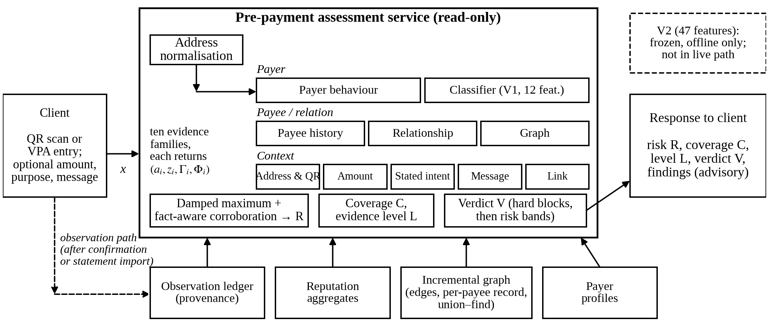
Fig. 1. Overall architecture of the proposed pre-payment risk-assessment framework. Solid arrows denote the read-only assessment path; the dashed arrow denotes the observation path, which writes to the store only after a payment is confirmed or a statement is imported. The live classifier family uses V1; V2 is frozen and evaluated offline.

B. Pre-Payment Workflow and Observation Path
Two paths touch the store (Fig. 2). The assessment path only reads it. The observation path writes to it only when a payment is recorded, either on the payer’s confirmation or on statement import. The request being assessed therefore cannot influence the state against which it is assessed. All addresses pass through a single normalisation function. Every recorded payment carries a provenance label (SYSTEM_CONFIRMED, STATEMENT_OBSERVED or OTHER_OBSERVED) and a deduplication key, so a payment reaching the ledger by two routes is recorded once. Statement ingestion classifies each counterparty field as a complete VPA, a partial VPA fragment, a non-VPA identifier, a name only, or unknown; only complete VPAs are joined to a payee address directly. Timestamps are normalised to Indian Standard Time (IST).
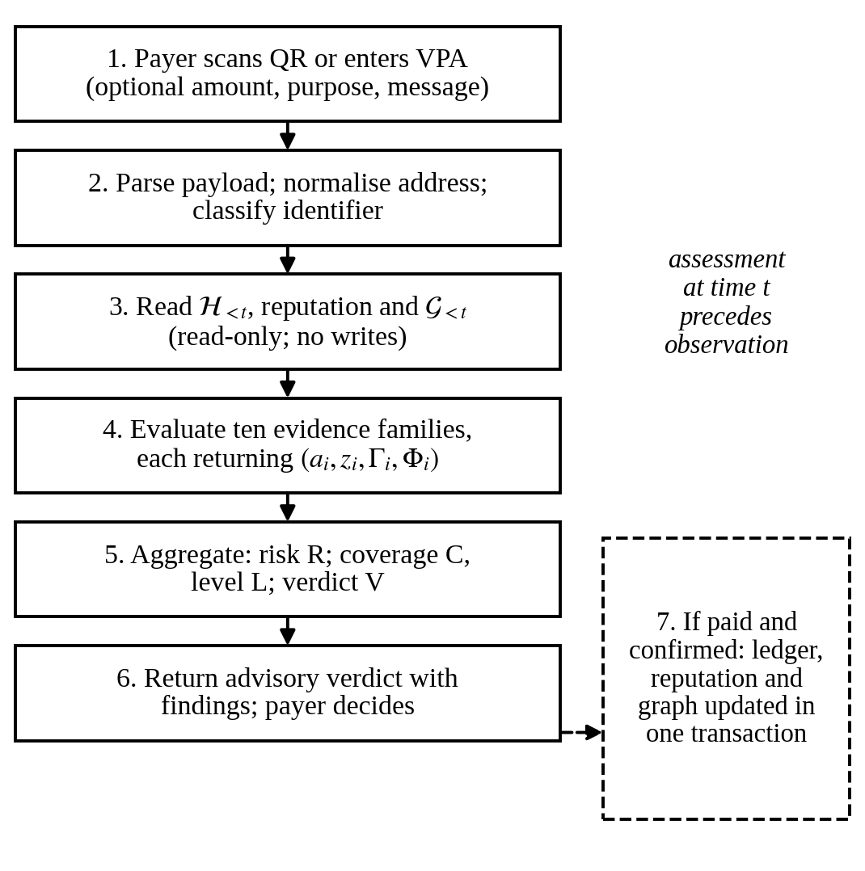
Fig. 2. Pre-payment assessment workflow. The assessment at time t reads only state recorded before t; the observation path updates the ledger, reputation aggregates and graph in one transaction after the payer’s decision.

C. Evidence Families
Each family returns an evidence record with availability, score, severity, findings and a set of facts. Facts are drawn from a closed vocabulary of fourteen underlying observations — five payer-side, four payee-side and five contextual facts (for example, HOUR_ANOMALY, PAYEE_SHAPE and GRAPH_POSITION). Facts identify what was observed, independently of which family observed it. Table II summarises availability and contribution to risk.
The address and QR family checks address form, handle plausibility and visually confusable characters. For a QR code, it also checks whether the payload is a payment request and whether its displayed payee name matches its address. The payee-history family reads reputation aggregates across all observed payers: observation age, distinct payers, repeat payers, amount uniformity, and reports or blocks. For an address with no recorded payments, it raises an “unseen payee” finding weighted at 6 points. This finding records that the deployment has no history for the address, which is ordinary for a new payee but also true of a newly created collection account. Six points is well below the 22-point WARN threshold. The payer-behaviour family compares the request with the payer’s profile: relative amount, hour, daily activity, payee novelty and the payer’s record of failed payments. The relationship family reports $κ\left(u,p\right)$, carries the PAYEE_FAMILIARITY fact, and is always scored zero. The amount-context family compares the amount with the rail limit and with transfers plausible to an unfamiliar payee. The stated-intent, message-pressure and link-safety families examine a stated purpose, coercive cues in a supplied message, and URLs. The classifier family maps a calibrated probability to a bounded score. The graph family scores only positional findings.

TABLE II
Evidence Families, Availability and Contribution to Risk
Family | Available when | Contribution to risk | Principal facts | Coverage weight $c_{i}$
Payee history | An address can be read | Scored; unseen payee → 6-point finding; blocked payee → hard block | PAYEE_SHAPE, PAYEE_REPORTS | 24
Relationship | Authenticated payer present | Informational ($z=0$) | PAYEE_FAMILIARITY | 18
Payer behaviour | Payer profile exists | 0 if raw score < 25, else 12–52 | AMOUNT_DEVIATION, HOUR_ANOMALY, VELOCITY_DAILY, PAYEE_FAMILIARITY, PAYER_RELIABILITY | 16
Classifier (V1 in prototype) | Amount known, profile, ≥ 5 prior payments | 0–18 below $θ$; 30–66 above | Counterfactually attributed subset | 12
Address and QR | Always | Scored; malformed address or non-payment payload → hard block | ADDRESS_INTEGRITY | 11
Graph | Payee present in graph | Position findings only | GRAPH_POSITION; shape findings share PAYEE_SHAPE (weight 0) | 8
Amount context | Amount known | Scored; above rail limit → hard block | AMOUNT_ABSOLUTE | 5
Message pressure | Message supplied | Scored; 0 if only weak cues | MESSAGE_COERCION | 3
Link safety | Always (0 if no link) | Scored | LINK_REPUTATION | 2
Stated intent | Purpose stated | Scored | STATED_PURPOSE | 1

D. Incremental Payer–Payee Graph
Each recorded payment from $u$ to $p$ updates a directed edge $\left(u,p\right)$, which carries a payment count and first and last timestamps. It also updates a per-payee aggregate record and merges the connected components of $u$ and $p$ in a union–find structure. These updates run in the same database transaction that records the payment, so the graph cannot drift from the ledger. The per-payee record holds the distinct-payer count, the repeat-payer count, the payment count, and the first and last arrival and activity times. Components are only ever merged, which matches an append-only ledger. The assessment path reads the graph through a read-only view: shape quantities come from one indexed lookup, and overlap comes from a bounded two-hop query for the peer that shares the most payers with $p$ (Fig. 3).
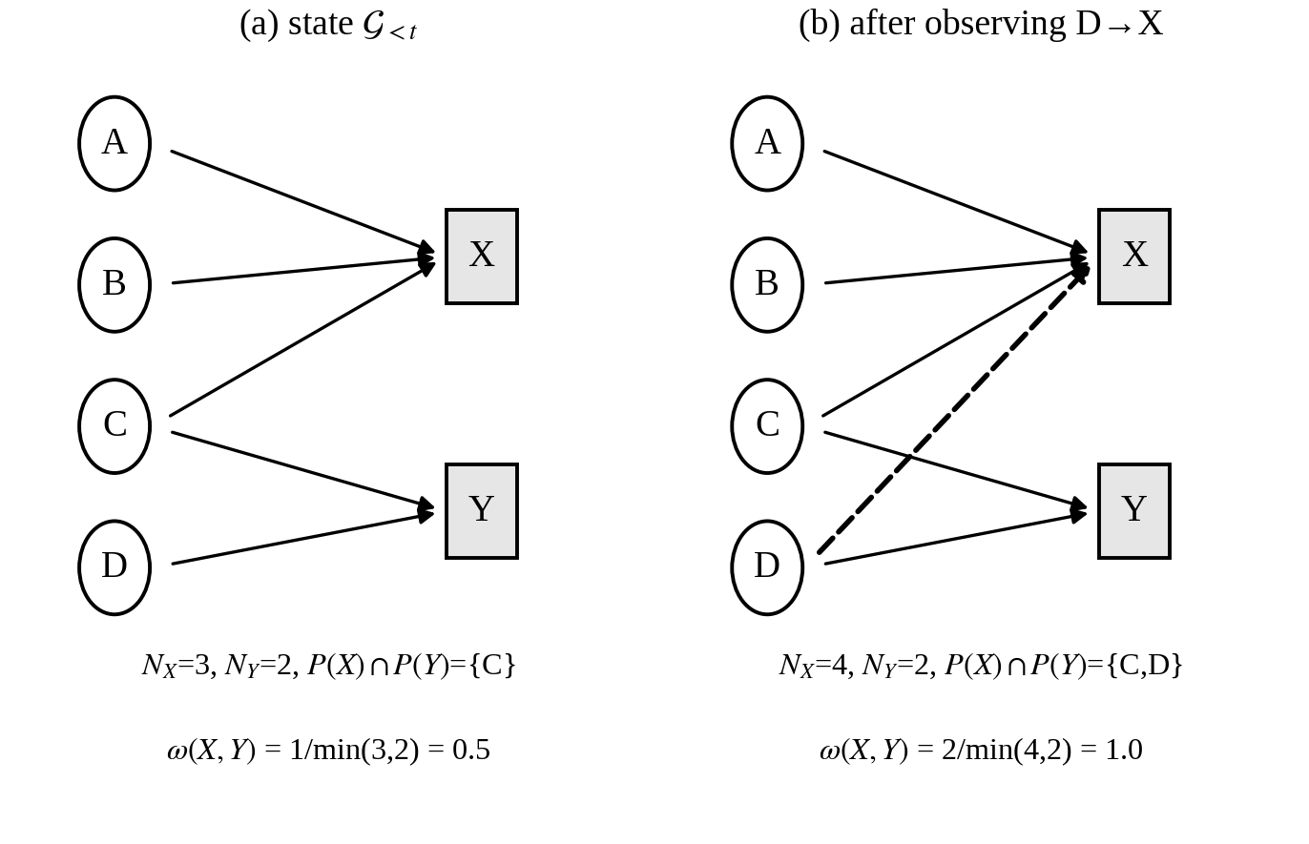
Fig. 3. Incremental payer–payee transaction graph update and feature extraction (illustrative, not experimental data). (a) Payees X and Y share payer C, giving an overlap ratio of 0.5. (b) After observing D→X, the shared set is {C, D} and the ratio is 1.0. No finding would fire, because the implemented gates require at least ten payers on each address.
Two kinds of graph finding are distinguished. Shape findings describe the payee’s own neighbourhood: many one-time payers, all payers arriving within a short window, or a high rate of payments from new payers. Because they restate what the payee-history family already scores, they carry zero weight and share the PAYEE_SHAPE fact. A position finding fires when a substantial share of the payee’s payers also pay a single other address and almost none pays either address twice. That pattern is consistent with collection accounts sharing a victim pool and not with independent merchants, whose customers return. Only a position finding earns GRAPH_POSITION and a non-zero graph score. Component size is recorded but is never a finding.
This component is explicit graph analytics. It learns no embeddings and performs neither dense-subgraph peeling as in Spade+ [5] nor temporal graph representation learning as in PGLTSE [7]. The trade-off is deliberate: explicit features can be named in a finding and computed within one request on a small, partially observed graph, but they capture only patterns specified in advance.

E. Fraud-Probability Model
The classifier is a histogram-based gradient-boosting model with balanced class weights, wrapped in five-fold isotonic calibration, with its threshold selected on a validation split. It is one evidence source among ten, contributing a bounded score that cannot reach BLOCK when it is the only active family. The running prototype serves V1, the 12-feature representation. V2, the 47-feature representation, is frozen and evaluated offline only (Section VI-D).

F. Explanation Interfaces
Explanations are produced at two levels. At the evidence level, each assessment returns its findings, each with a severity, a plain-language message, the reporting family and the corroborating facts. This is the primary user-facing explanation. At the model level, the prototype also provides an explanation interface (an /explain endpoint and an Explainability screen). For a recorded transaction, this interface computes model-agnostic SHAP values for the V1 feature vector against a stored background sample, with the calibrated V1 probability as the explained function. These attributions describe the classifier; they are neither the verdict nor a substitute for the findings. For the offline analysis in Section X, SHAP values are computed instead on the uncalibrated booster of the first calibration fold (Section VII-G).

G. Deployment Boundary
The prototype does not initiate or intercept payments, and no real-time external verification takes place. Its payment history consists of payments confirmed through the application and statements that users choose to import, so payee-side evidence is limited to what the deployment itself has observed.

V. Mathematical Formulation

A. Clamped Mapping and Temporal Boundary
Let $F=\{1,…,10\}$ index the families and $h\left(t\right)$ the IST hour of $t$. Measurements are converted into scores by the clamped linear map
$$g\left(v;v_{0},v_{1},y_{0},y_{1}\right)=y_{0}+\left(y_{1}−y_{0}\right) clip​\left({v−v_{0}}/{v_{1}−v_{0}},0,1\right) \left(3\right)$$
where $clip\left(⋅,0,1\right)$ bounds its argument to $\left[0,1\right]$. With $τ\left(o\right)$ the time of observation $o$ in ledger $H$, the history available to a live assessment is
$$H_{<t}=\{ o∈H:τ\left(o\right)<t \} \left(4\right)$$
The pair history applies (4) explicitly. Reputation aggregates and the graph are read in their current state, which equals the pre-$t$ state for a live request because the observation for $x$ is written only after confirmation. The prototype keeps no time-indexed aggregates, so the equality does not hold for retrospective replay against a store that already contains later payments.

B. Evidence Records
Family $i$ returns
$$e_{i}\left(x\right)=\left(a_{i}, z_{i}, Γ_{i}, Φ_{i}\right) \left(5\right)$$
where $Γ_{i}$ are its findings and $Φ_{i}⊆V$ its facts from the fourteen-fact vocabulary $V$. If $a_{i}=0$, then $Γ_{i}=Φ_{i}=∅$. A family is active if $a_{i}=1$ and $z_{i}>0$. The amount-context and graph families score the sum of their finding weights, capped at 100; the relationship family is fixed at $z=0$; the other families use their own bounded rules.

C. Payer and Payee Quantities
Let $n_{u}$ be the payer’s number of prior outgoing payments and $b_{u}$ their median amount. The relative amount $a/b_{u}$ is measurable only if $n_{u}≥5$ and $b_{u}>0$. With ${\overset{‾}{h}}_{u}$ the payer’s most active hour,
$$ν\left(t\right)=1\left[h\left(t\right)<6∨h\left(t\right)≥22\right] \left(6\right)$$
$$d_{u}\left(t\right)=min\left(\left|h\left(t\right)−{\overset{‾}{h}}_{u}\right|, 24−\left|h\left(t\right)−{\overset{‾}{h}}_{u}\right|\right) \left(7\right)$$
The payer-behaviour rules produce a raw score $r_{u}$, which is mapped to a family score $z_{pb}=0$ when $r_{u}<25$ and $z_{pb}=round\left(g\left(r_{u};25,85,12,52\right)\right)$ otherwise, so that an ordinary payment does not place a floor under risk. For payee $p$, let $N_{p}$ be the number of distinct payers and $N_{p}^{rep}$ the number who paid more than once. The repeat ratio is
$$r_{p}=N_{p}^{rep}/max\left(N_{p},1\right) \left(8\right)$$
which is treated as measurable only when $N_{p}≥5$. The payer-relative novelty indicator $η\left(u,p\right)$ is 0 if $κ\left(u,p\right)=$ ESTABLISHED and 1 if it is NEW.

D. Graph State and Overlap
The graph state and the payer set of $p$ are
$$G_{<t}=\left(V_{<t},E_{<t}\right), P\left(p\right)=\{u:\left(u,p\right)∈E_{<t}\} \left(9\right)$$
From the per-payee record the implementation derives the arrival span, lifespan, payment rate and component size. For a peer $p′$, the overlap ratio is
$$ω\left(p,p′\right)=\frac{\left|P\left(p\right)∩P\left(p′\right)\right|}{min\left(\left|P\left(p\right)\right|,\left|P\left(p′\right)\right|\right)} \left(10\right)$$
Let $p^{⋆}$ be the peer that maximises the shared count. The overlap is read only if both addresses have at least ten payers, and it is discounted if the peer’s own repeat ratio is at least 0.1. A position finding fires when $\left|P\left(p\right)∩P\left(p^{⋆}\right)\right|≥4$, $ω\left(p,p^{⋆}\right)≥0.6$ and $r_{p}<0.1$.

E. Classifier Probability and Evidence Score
Let $ϕ\left(x\right)∈R^{d}$ be the feature vector ($d=12$ for V1 and 47 for V2), with unmeasured entries left missing, and let $θ$ be the threshold chosen on validation. The calibrated probability is
$$π\left(x\right)=\hat{P}\left(y=1∣ϕ\left(x\right)\right) \left(11\right)$$
The classifier family is available only if the amount is known, a payer profile exists and $n_{u}≥5$. Its score is
$$z_{ml}=\left\{\begin{matrix}round g\left(π;0,θ,0,18\right), & π<θ \\ round g\left(π;θ,0.8,30,66\right), & π≥θ\end{matrix}\right. \left(12\right)$$
The ceiling of 66 lies below the BLOCK boundary of 70. Facts are attributed to the classifier counterfactually. For a candidate fact $v$, a probe $ϕ^{\left(−v\right)}\left(x\right)$ neutralises the inputs underlying $v$: payee-history inputs are set to missing, and payer-side inputs are set to values describing the payer’s ordinary behaviour. Then
$$v∈Φ_{ml}⇔π\left(x\right)−π\left(ϕ^{\left(−v\right)}\left(x\right)\right)≥max\left(0.01, 0.15 π\left(x\right)\right) \left(13\right)$$
These probes never alter $z_{ml}$.

F. Risk, Corroboration and Coverage
Let $z_{\left(1\right)}≥…≥z_{\left(n\right)}$ be the scores of the active families. The base risk is the damped maximum
$$R_{0}=min\left(99, round\left(z_{\left(1\right)}+β\sum_{j=2}^{n}{z_{\left(j\right)}}\right)\right), β=0.4 \left(14\right)$$
with $R_{0}=0$ when no family is active. Let $A=\{i:a_{i}=1, z_{i}≥20\}$, let $Φ^{⋆}=⋃_{i∈A}Φ_{i}$, and let $A^{⋆}⊆A$ be the families reporting at least one fact. The corroboration strength and final risk are
$$k=min\left(\left|Φ^{⋆}\right|,\left|A^{⋆}\right|\right), R=min\left(99, R_{0}+B\left(k\right)\right) \left(15\right)$$
where $B\left(k\right)=0$ for $k<2$ and $B=6,14,22,28$ for $k=2,…,5$, rising to a maximum of 32 for $k≥6$. Counting families prevents a single family from corroborating itself, and counting facts prevents several families that read one observation from appearing to agree. Coverage is
C=round100 i​aici/i​ci 16
where the $c_{i}$ are fixed implementation weights summing to 100 and listed in Table II. These weights value availability, not risk, and do not enter (14) or (15). Fig. 4 summarises the aggregation.
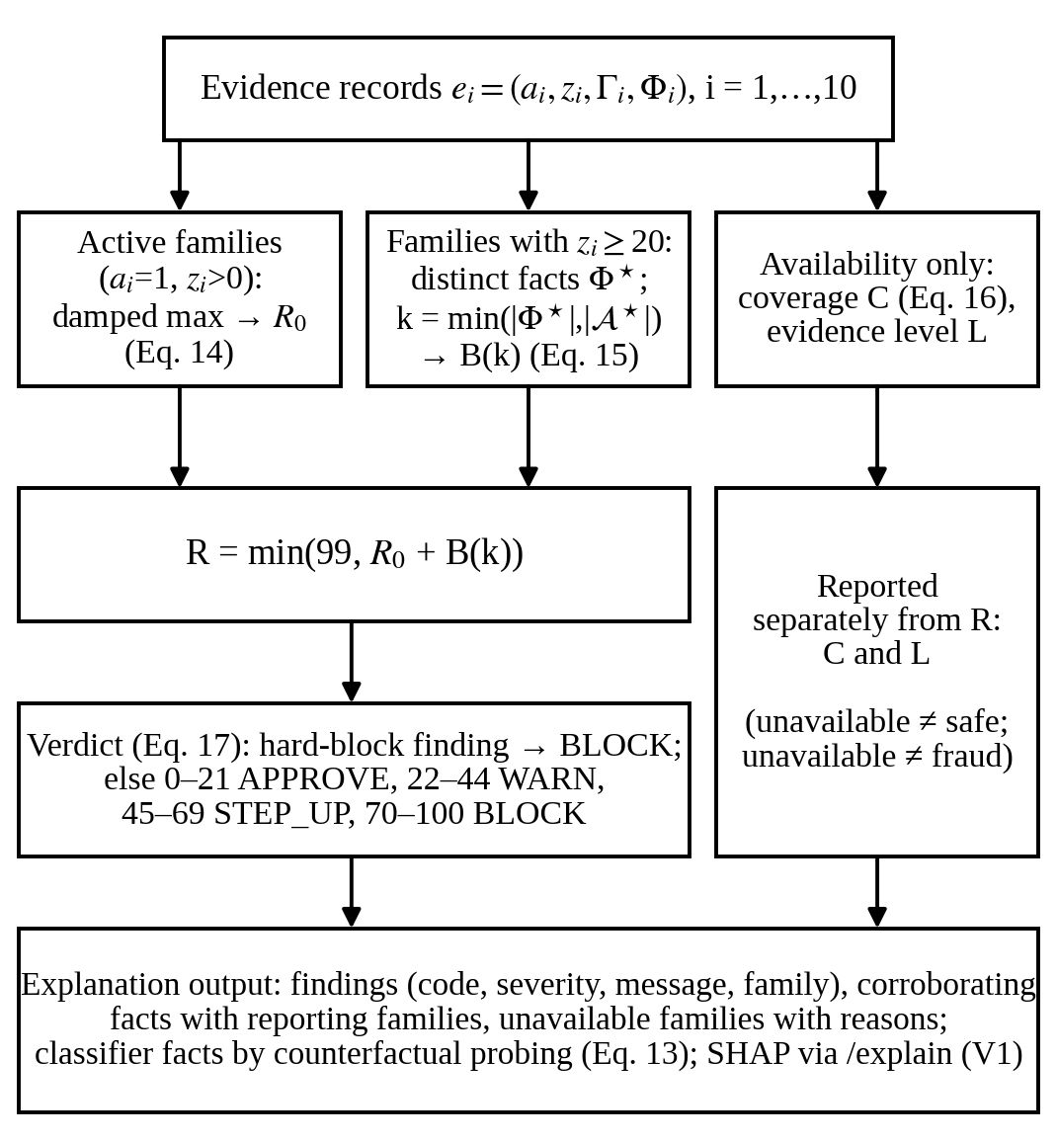
Fig. 4. Evidence aggregation and explainability pipeline. Risk is formed from active family scores by (14) and (15); coverage and evidence level depend only on availability (16) and are reported separately; the verdict applies (17); findings, corroborating facts and unavailable families form the explanation output.

G. Verdict Mapping
Let $B$ be the hard-block set: a blocked payee, a malformed address, a non-payment payload, a missing payee, an empty request, and an amount above the rail limit. Then
$$V=\left\{\begin{matrix}\text{BLOCK}, & Γ∩B≠∅\text{ or }R≥70 \\ \text{STEP_UP}, & 45≤R≤69 \\ \text{WARN}, & 22≤R≤44 \\ \text{APPROVE}, & 0≤R≤21\end{matrix}\right. \left(17\right)$$
where $Γ=⋃_{i}Γ_{i}$. The BLOCK band is nominally 70–100; because $R$ is capped at 99, it covers 70–99 in practice. The verdicts are advisory outputs of the aggregated risk, not ground-truth classes.

VI. Data Construction and Feature Engineering

A. Synthetic Transaction Corpus
Labelled UPI fraud data held by banks, PSPs and the national switch are not publicly released. No private NPCI data, bank-owned corpus or PSP production dataset was used in this study. The classifier is trained and evaluated on a synthetic corpus produced by a purpose-written simulator, in the tradition of agent-based payment simulators such as PaySim [18]. The simulator supports controlled experiments with a known generating process and makes every reported number reproducible from a fixed seed; it does not establish how the system would perform on real UPI traffic.
The corpus is generated with 120,000 transactions, a nominal fraud rate of 0.012, 2,000 simulated payers and seed 42. The realised corpus contains 1,419 fraudulent transactions, a prevalence of 1.183% (Table III). Each simulated payer has a typical amount drawn from a right-skewed log-normal distribution (median of approximately Rs 270), a usual hour of activity, a daily transaction rate and a number of habitual payees. A 12% segment of payers makes large payments (rent, fees, deposits) as an ordinary matter, so that large amounts do not occur almost exclusively in fraudulent rows. All amounts respect the per-transaction UPI limit, and both classes can reach it.
Each transaction is generated for a randomly chosen payer. With probability equal to the fraud rate it is produced by one of four fraud scenarios, and otherwise as legitimate activity. The scenario mixture is fixed at social engineering 50%, mule collection 22%, account takeover 20% and card testing 8%. These proportions are simulator-controlled design choices, not estimates of the composition of UPI fraud.
Labels are assigned by the generating process rather than by a rule over features. The scenarios are also built to overlap with legitimate behaviour. Legitimate payers sometimes send large amounts to new payees, some account-takeover payments go to payees the victim had already paid, and some social-engineering payees are aged accounts that resemble small merchants. Two separability artefacts found in earlier generator versions were removed before the reported experiments. The corpus is row-level: each row represents the evidence state at the moment one payment is about to be made, sampled from scenario-conditional distributions, rather than a time-ordered ledger replayed through the running system.
TABLE III
Dataset Characteristics (Synthetic Corpus, Seed 42)
Item | Value
Transactions / simulated payers | 120,000 / 2,000
Fraudulent transactions | 1,419 (1.183%)
Train / validation / test rows | 72,000 / 18,000 / 30,000
Fraudulent rows per split | 851 / 213 / 355
Fraud scenario mixture (simulator setting) | SE 50%, MC 22%, AT 20%, CT 8%
Test fraud by scenario | SE 182, MC 80, AT 73, CT 20
Rows with hidden payee history | 29,376 (24.48%)
SE = social engineering; MC = mule collection; AT = account takeover; CT = card testing. Proportions are not real-world prevalence estimates.

B. Behavioural and Payee Features (V1)
The V1 representation contains twelve features. Seven describe the payer and the payment:
- amount;
- amount_over_user_avg (amount divided by the payer’s median prior payment);
- is_night, as defined in (6);
- hours_from_usual, as defined in (7);
- seconds_since_last_txn, capped at one day;
- txns_last_hour;
- txns_today_over_avg.
Five describe the payee: payee_is_new (payer-relative novelty), payee_age_days, payee_distinct_payers, payee_repeat_ratio as in (8), and payee_history_available.
A deployment observes a payee only after one of its users, or an imported statement, has recorded a payment to it. An earlier pipeline substituted constants for missing payee values, which in effect described every unknown address as moderately established. The current pipeline substitutes nothing. When the payee’s history is unavailable, the three payee-history values are set to missing (NaN) and payee_history_available is set to 0. When a history exists but the payee has fewer than five distinct payers, the exact counts are kept and only the repeat ratio is set to missing. The histogram-based learner routes missing values natively [20], [22].
The simulator reproduces unavailability with an observation mask, under which the probability that a payee’s history is visible rises smoothly with its distinct-payer count (half-saturation at nine payers). The mask hides payee history on 29,376 of the 120,000 rows (24.48%). The simulated fraud prevalence is 1.729% among hidden-history rows and 1.005% among visible-history rows. This difference is a property of the masking rule, which ties visibility to payer count, and is not causal evidence that missing history indicates fraud. It has one consequence that must be stated. At the aggregation level, an unavailable family contributes no rule-based score merely because it is unavailable. However, payee_history_available is itself a classifier feature, so missingness can influence the learned probability. The pipeline reports this availability bias on every run, and automated tests bound it and check that the availability flag alone does not separate the classes strongly.

C. Graph-Derived Features
In the live system, the incremental graph state (9) supplies the per-payee quantities of Section V-D, including the overlap ratio (10). V2 includes seven graph features: arrival_span_days, lifespan_days, payments_per_day, component_size, shared_payer_peak, overlap_ratio and graph_available. Raw degree is not treated as fraud evidence. Overlap is read only when both addresses have at least ten payers, and it is discounted when the peer’s payers commonly return.
In the synthetic corpus these features are not computed by running the incremental graph over a simulated ledger. They are sampled per row from scenario-conditional distributions that mirror the production gates: the whole group is missing whenever payee history is hidden, and the overlap ratio is missing below the ten-payer gate. The predictive experiments therefore evaluate the contribution of graph-derived feature channels under a controlled simulation. The incremental graph implementation itself is validated separately by software tests (Section X-L).

D. V1 and V2 Feature Representations
The running prototype retains V1, whereas V2 represents an expanded research configuration that was frozen and evaluated offline (Table IV). V2 contains 47 features in nine groups:
- payer timing (2);
- amount (2);
- velocity (3);
- payee (5), comprising the four V1 payee-history features and a phone-number-address flag;
- relationship (4), comprising payee_is_new, prior payments to the payee, days since the first such payment, and an availability flag;
- graph (7);
- message (18), comprising ten coercion-cue indicators, a coercion probability and score, a weak-cues flag, four text statistics, and an availability flag;
- link (3);
- stated intent (3).
The V2 generator first calls the V1 generator and keeps its output bit-for-bit. It then draws every added column from a separate random stream (seed offset 10,000), and an automated check asserts that the V1 columns are unchanged.
The V2 channels are simulated. The simulator draws from scenario-conditional probabilities chosen by the designers whether a message accompanies a payment, which kind it is, whether it carries a link, and which purpose is stated. These probabilities overlap by design; for example, a message is present on 55% of legitimate rows and 62% of social-engineering rows. Message texts come from a templated pool of 1,022 messages (364 scam, 557 hard negatives, 101 easy negatives) written for the project rather than collected from real traffic. Message and link features are computed by the same extractors that the service uses, but the coercion model that produces one message feature was fitted on the same templated pool. Gains obtained by V2 are therefore evidence about the architecture under the simulator’s assumptions, not about production performance.
TABLE IV
V1 and V2 Feature Representations
Aspect | V1 (running prototype, baseline) | V2 (research, offline)
Features | 12 | 47 in 9 groups
Groups | Payer timing, amount, velocity, payee | V1 groups + phone-address flag, relationship, graph, message, link, intent
Missing values | NaN; one availability flag | NaN; flags for payee, relationship, graph, message, intent
Added channels | — | Simulator-generated
Learner | HGB, balanced weights, isotonic (5-fold) | Same
Threshold (validation, FPR ≤ 1%) | 0.1174 | 0.1123
Status | Served by prototype | Frozen; offline only

E. Temporal Boundary and a V1 Limitation
The live serving path is designed around pre-payment information. The assessment path is read-only; the pair history uses the strict inequality of (4); velocity inputs are filtered the same way; and tests confirm that a check leaves stored graph and reputation tables unchanged. The offline V2 experiment generates rows and graph-derived features through the simulator and does not replay the live graph cache chronologically. Its temporal boundary therefore holds by construction rather than by computation.
One V1 limitation is reported as it stands. When the payer’s usual hour is unavailable, V1 records hours_from_usual as 0, the same value as a payment made exactly at the usual hour, so an unmeasured deviation is indistinguishable from a measured zero deviation. V1 is a frozen artefact and was not altered, and V2 inherits the same encoding for this feature.

VII. Fraud-Risk Models

A. Learning Problem
Given the feature vector $ϕ\left(x\right)$ and label $y∈\{0,1\}$, with $y=1$ denoting fraud, the task is to estimate $π\left(x\right)$ as defined in (11) and to choose a threshold $θ$. At about 1.2% prevalence, a classifier that labels every payment legitimate is correct on almost 99% of payments, so accuracy is not used as a headline metric. The evaluation instead emphasises ranking quality under imbalance, recall at a fixed false-positive budget, and calibration [3], [12], [13].

B. V1 Model
V1 is a histogram-based gradient-boosted decision-tree model [17], [20], implemented with scikit-learn’s HistGradientBoostingClassifier [22] and wrapped in CalibratedClassifierCV with isotonic regression and five folds. The booster uses 300 iterations, a learning rate of 0.08, at most 31 leaves per tree, balanced class weights and a fixed random state. Five-fold calibration fits five booster–calibrator pairs and averages their calibrated probabilities. This is the standard behaviour of the calibration wrapper, not a heterogeneous ensemble. Calibration matters here because the probability is mapped to an evidence score with fixed breakpoints in (12) and is used for fact attribution in (13).

C. V2 Model
V2 applies the same modelling family to the expanded representation, and no second algorithm is introduced. Its configuration was fixed entirely on the validation split. First, four model families were compared on the full V2 features: V1-configured gradient boosting; a random forest (300 trees, minimum leaf size 2, balanced-subsample weights); extremely randomised trees (300 trees, minimum leaf size 2, balanced weights); and balanced, standardised logistic regression, with median imputation for the last three. They were ranked by validation PR-AUC and then by validation recall at 1% FPR. Second, a feature-group ablation on the validation split selected the full nine-group set. The chosen configuration was then fitted, calibrated, given its threshold on validation, and frozen together with a dataset fingerprint containing hashes of the generators, message corpus and coercion weights. The frozen configuration records that no test rows were used in any decision.

D. Class Imbalance
Five aspects of imbalance handling are kept distinct:
- Data prevalence. The data keep a prevalence of 1.183%, and each split is stratified to it.
- Training weights. The booster uses balanced class weights, scaling each class’s loss contribution inversely to its frequency.
- No resampling. No SMOTE [19], random oversampling, undersampling or generative minority sampling is used.
- Calibration. Class weighting shifts the effective class prior and inflates minority-class scores; isotonic calibration returns the probabilities to the observed scale.
- Threshold selection. This is a separate step, described in Section VII-E.

E. Threshold Selection
Probability estimation, threshold selection and final evaluation are separated. On the validation split, $θ$ is set to the threshold with the highest recall among those whose validation false-positive rate (FPR) does not exceed 1%. It is then applied unchanged to the test split. The selected thresholds are 0.1174 for V1 and 0.1123 for V2. An independent re-derivation of the V1 threshold from the validation split agrees with the stored value to four decimal places. The artefacts record that neither test labels nor test features were used in selection. The classifier threshold $θ$ is distinct from the verdict bands in (17).

F. Calibration
Calibration is assessed with the Brier score [16]
$$BS=\frac{1}{n}\sum_{j=1}^{n}{{\left(π_{j}−y_{j}\right)}^{2}} \left(18\right)$$
and with the Brier skill score $BSS=1−BS/{BS}_{ref}$. Here ${BS}_{ref}=0.01169$ is the Brier score of a constant predictor that always outputs the base rate. Reliability curves are reported with quantile bins and with fixed-width bins, because at a 1% base rate quantile edges collapse near zero.

G. Explainability of the Classifier
Two offline analyses are computed for V2. Permutation importance [23] measures the mean decrease in test average precision over five permutations of each feature, applied to the calibrated model. SHAP values [21] are computed with a tree explainer on 200 test rows, applied to the uncalibrated booster of the first calibration fold. Their magnitudes therefore explain that booster’s raw output and do not decompose the calibrated probability. Isotonic calibration is monotone, so it preserves the ordering of predictions but not attribution magnitudes. Separately, the prototype’s explanation interface computes model-agnostic SHAP for V1 against the calibrated probability (Section IV-F). Neither form of attribution establishes causal influence.

VIII. Evidence Aggregation and Explainability

A. Availability, New Payees and Missing Evidence
In the running prototype, all ten families of Table II are evaluated for every request, and the classifier family uses V1. Message, link, stated-purpose, relationship and graph evidence therefore reach the live risk score through their own rule-based families, whereas V2 receives those channels as classifier inputs and is not served.
An unavailable family carries no score, findings or facts, so it neither raises nor lowers the rule-based risk. “New” is different from “history unavailable.” An address that can be read but has never been observed keeps the payee-history family available, with the 6-point “unseen payee” finding. A family that cannot be evaluated at all is unavailable. A new payee therefore does not become WARN on novelty alone, since 6 points is below the 22-point threshold, although the finding can combine with other evidence through (14). Within the classifier, missingness is an input (Section VI-B). The entity status is descriptive and unscored, and no experimental payee is externally verified.

B. Fact-Aware Corroboration
Several families read overlapping inputs. The payer-behaviour rules and the classifier both examine the relative amount, hour, daily activity and payee novelty. The classifier and the payee-history family both depend on payee age, payer count and repeat ratio. The graph family’s shape findings restate the payee-history inflow pattern. Counting agreement by modules would therefore reward one observation several times. The implementation instead counts agreement over distinct facts, as defined in (15): graph shape findings collapse onto PAYEE_SHAPE, and only a positional overlap earns GRAPH_POSITION. For the classifier, declaring every fact it reads would let one probability supply up to six corroborations, so its facts are attributed by neutralising one input group at a time, as in (13). A constant named ML_CASTS_AGREEMENT_VOTE = False remains in the source from an earlier design, but it no longer governs behaviour. The set of non-voting families is empty, and the classifier participates in corroboration only through counterfactually attributed facts, each counted once across families.

C. Risk Versus Confidence
Risk $R$ measures how strongly the available evidence indicates that a payment should not proceed. Confidence, reported as coverage $C$ with level $L$, measures how much of the designed evidence was available. It depends only on availability and is not the classifier’s probability. The two can therefore combine in any way. A reported address paid by a payer with no history yields high risk with limited evidence. A routine payment to a long-established payee yields low risk with strong evidence. Low risk with limited evidence is also possible. Low confidence is never read as low risk, and high coverage does not mean that a payment is safe.

D. Aggregation and Verdict in Practice
The base risk in (14) takes the highest active score in full and 40% of each further score. The bonus in (15) is added only for agreement across distinct facts, and the result is capped at 99. The relationship family, which is scored zero, never participates in corroboration. The graph family participates only when a positional finding fires, and the classifier, capped at 66, needs at least one other contributing family to reach BLOCK. The verdict bands of (17) are advisory:
- APPROVE indicates risk below the configured intervention threshold, not a guarantee of safety.
- WARN presents evidence that the payer should see.
- STEP_UP recommends verifying the payee through an independent channel.
- BLOCK recommends not proceeding.
No verdict holds or reverses a payment.

E. Explanation Output
Each assessment returns findings with a code, severity and plain-language message. It also lists the facts that participated in corroboration and the families that reported each one, so the response can state when several families agreed about a single observation. User-facing explanations cover unusual payer behaviour, prior payments to this payee (including partial-identity matches from statements), payee history, graph overlap, detected message and link cues, and the model’s calibrated probability relative to its threshold. The response also lists any evidence that could not be evaluated, with the reason. SHAP attributions for the classifier are available through the explanation interface. The explanations describe the evidence behind a verdict; they do not prove that a payment is fraudulent.

IX. Experimental Methodology

A. Setup
All predictive experiments use the corpus of Table III and follow the workflow in Fig. 5. A quarter of the rows is first held out as the test split, and 20% of the remainder is taken as validation. Both splits are stratified on the label with random state 42, which yields 72,000 training, 18,000 validation and 30,000 test rows; the artefacts verify that the index sets are disjoint. V1 and V2 use the identical split. Because the corpus is row-level, the split is random rather than chronological. Payments of one simulated payer can appear in several splits, and although no payer identifier is a feature, generalisation to unseen payers is not measured.
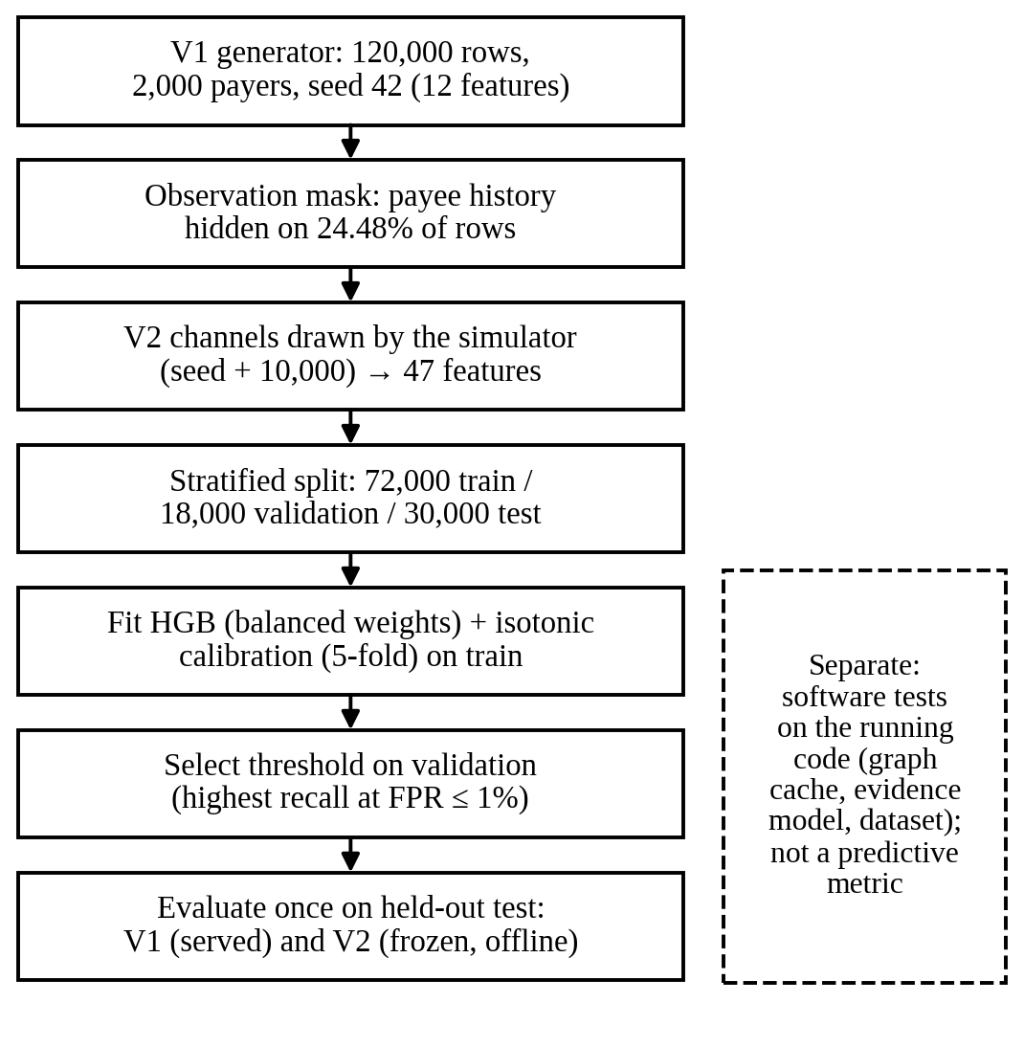
Fig. 5. Experimental evaluation workflow. Model selection and threshold choice use only the validation split; each classifier is measured once on the held-out test split. Software tests on the running code are a separate form of evidence.

B. Evaluation Protocol and Result Categories
Three categories of result are reported and never mixed:
- Validation results come from the validation split and were used for decisions: the V2 model family and feature set, and the thresholds of both models.
- Held-out test results come from a single evaluation of the stored V1 artefact (without refitting) and of the frozen V2 artefact. The ablation and model-family comparison are also test measurements, but of separately re-fitted, uncalibrated models under their own protocol.
- Software test results verify implementation properties of the running code and are not predictive metrics.

C. Metrics
With fraud as the positive class,
$$Precision=\frac{TP}{TP+FP}, Recall=\frac{TP}{TP+FN} \left(19\right)$$
$$FPR=\frac{FP}{FP+TN}, F_{1}=\frac{2⋅Precision⋅Recall}{Precision+Recall} \left(20\right)$$
The area under the precision–recall curve (PR-AUC), computed as average precision, is the primary threshold-independent metric. A random ranking scores the prevalence (about 0.012), and, unlike the area under the ROC curve (ROC-AUC), PR-AUC is directly sensitive to how false positives dilute alerts under severe imbalance [12], [13]. ROC-AUC is reported as a secondary measure. Precision, recall, FPR and $F_{1}$ are computed at the operating threshold as in (19) and (20). Recall at about 1% FPR is the test recall at the validation-selected threshold, reported together with the realised test FPR. The Brier score and BSS follow (18).

D. Evaluation Target
The ground truth is binary, so the primary confusion matrix is the 2×2 matrix of the classifier flag against the fraud label. The advisory verdicts are outputs of the aggregated risk rather than labelled classes, so no four-class verdict confusion matrix is constructed. The predictive experiments do not measure the verdict distribution of the full ten-family system.

E. Scenario-Wise, Ablation and Missing-Evidence Analyses
Recall is reported per scenario at the overall threshold, because aggregate recall can conceal a scenario that is barely detected. Scenario results are conditional on the simulator’s scenario definitions and mixture.
V1 ablation. The V1 features are split into a payer half (seven features) and a payee half (five features). Payer-only, payee-only and full models are trained in the V1 configuration, each thresholded on validation. The reported quantity is the full model’s social-engineering recall minus that of the stronger half.
V2 ablation. Uncalibrated gradient boosting is re-fitted on six nested feature sets (Section X-J), on two leave-one-out sets and on a V1-feature reference. Each model receives its own validation threshold and a single test measurement, and the model-family comparison uses the same protocol.
Missing evidence. For each generated corpus, the pipeline reports the hidden-history share and the prevalence among hidden and visible rows. Test performance is not broken down by availability in the artefacts.

F. Software Validation, Latency and Reproducibility
The graph implementation is not executed by the predictive experiments. Instead, it is validated by software tests on the running store, which cover six properties:
- edge creation and increment, the payer and repeat-payer counts, and the arrival window;
- agreement between aggregates and edges, component merging, transactional rollback, and concurrent observations;
- the absence of writes or graph rebuilds during a check;
- the query count as the store grows;
- that later observations do not rewrite earlier readings;
- that positional facts are emitted only under the stated gates.
Further modules test the evidence model, evidence availability and the V2 dataset. Spade+ and PGLTSE were not re-implemented, so no numerical comparison with them is made.
The artefacts contain no latency benchmark, and no response-time figures are reported. The corpus is deterministic given the seed, with dataset, model and corpus hashes recorded in manifests. The environment was Python 3.10.12 with numpy 2.2.6, pandas 2.3.3, scikit-learn 1.7.2, scipy 1.15.3 and joblib 1.6.0. The repository state is discussed in Section XII-I.

X. Results

A. Experimental Setting
Unless stated otherwise, the results are held-out test results on 30,000 payments: 355 fraudulent (182 social engineering, 80 mule collection, 73 account takeover, 20 card testing) and 29,645 legitimate. V1 and V2 are evaluated on the same rows, and every threshold was chosen on validation under a 1% FPR budget. Sections X-B to X-K report predictive performance of the classifier component under controlled synthetic evaluation. They do not measure the complete ten-family verdict system, and the V2 graph, message, link and intent features are simulator-generated. Section X-L reports software validation.

B. V1 Baseline
On the held-out test split, V1, the calibrated 12-feature model retained by the running prototype, reaches a PR-AUC of 0.4860 and a ROC-AUC of 0.9652 (Table V). At its threshold of 0.1174, recall is 49.3% at a realised FPR of 0.945%, with precision 0.3846 and F1 0.4321. The confusion counts are TP = 175, FN = 180, FP = 280 and TN = 29,365. Recall varies sharply by scenario: 94.52% for account takeover, 100% for card testing, 63.75% for mule collection and 19.23% for social engineering. In the V1 ablation, the payer-only model recalls 3.85% of social-engineering payments, the payee-only model 11.54% and the full model 19.23%. The full model therefore exceeds the stronger half by 7.69 percentage points (approximately +7.7 pp). This is a scenario-specific difference, not a lift in overall recall.

C. V2 Primary Result
The frozen, offline V2 model reaches a held-out test PR-AUC of 0.7326 and a ROC-AUC of 0.9900. At its threshold of 0.1123, recall is 0.7803 at an FPR of 0.00995, precision is 0.4843 and F1 is 0.5976. Its Brier score is 0.00555, which corresponds to a Brier skill score of 0.525 (Table V). The validation results obtained when the threshold was chosen (PR-AUC 0.6995; recall 0.746 at FPR 0.00995) are close to the test results, which is consistent with the protocol having been followed. All figures come from one split and one seed, without confidence intervals or significance tests.
Compared with V1 on the same rows, PR-AUC rises from 0.4860 to 0.7326, and recall at the 1% budget from 49.3% to 78.03%, while false positives rise from 280 to 295. The expanded representation therefore performs better under the controlled synthetic evaluation. This difference should not be interpreted as a real-world performance gain, because the additional V2 channels are generated by the same simulator used for evaluation.
TABLE V
Classifier Performance: V1 vs. V2 (Held-Out Test Split, n = 30,000, 355 Fraudulent; Calibrated Models)
Metric | V1 (prototype) | V2 (offline)
PR-AUC | 0.4860 | 0.7326
ROC-AUC | 0.9652 | 0.9900
Threshold (from validation) | 0.1174 | 0.1123
Recall | 0.4930 | 0.7803
Precision | 0.3846 | 0.4843
F1 | 0.4321 | 0.5976
FPR | 0.00945 | 0.00995
Alerts raised | 455 | 572
Brier score | 0.00798 | 0.00555
Brier skill score | 0.317 | 0.525

D. Confusion Matrix
Table VI gives the V2 held-out confusion matrix. Of 29,645 legitimate payments, 29,350 (99.0%) are correctly left unflagged and 295 (1.0%) are flagged. Of 355 fraudulent payments, 277 (78.0%) are flagged and 78 (22.0%) are missed.
TABLE VI
V2 Confusion Matrix (Held-Out Test Split, Threshold 0.1123)
 | Predicted legitimate | Predicted fraud
Legitimate (29,645) | TN = 29,350 | FP = 295
Fraud (355) | FN = 78 | TP = 277

E. Precision–Recall and ROC Analysis
Fig. 6(a) shows the V2 precision–recall curve (average precision 0.7326) against a no-skill baseline equal to the test prevalence of 0.0118. The operating point lies at recall 0.780 and precision 0.484. Precision is near 1.0 at low recall and declines as recall increases, so alerts become progressively diluted by false positives. Fig. 6(b) shows the ROC curve (ROC-AUC 0.9900), with the operating point at FPR 0.0100 and a true-positive rate of 0.780. Because the negative class is very large, the ROC curve rises almost vertically, and the precision–recall view is the more informative of the two [12], [13].

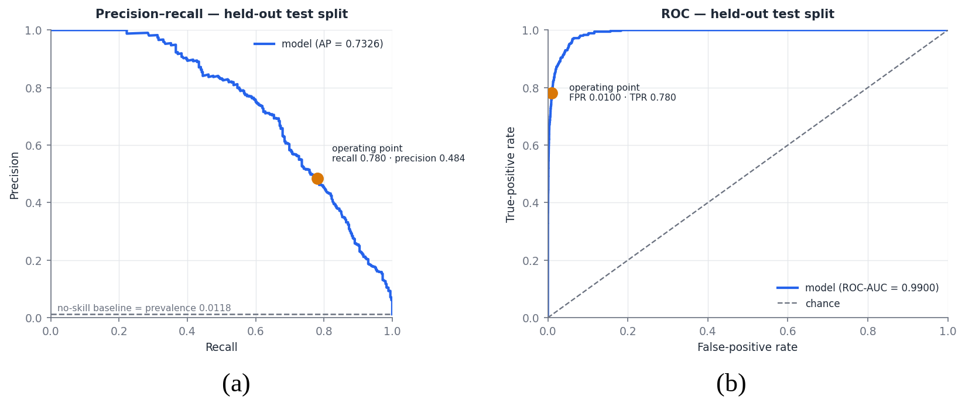
Fig. 6. Frozen V2 model on the held-out test split: (a) precision–recall curve with the no-skill baseline at the test prevalence; (b) ROC curve. Markers indicate the validation-selected operating point.

F. Recall at a Fixed False-Positive Rate
Fig. 7(a) plots achievable recall against FPR in the low-FPR region with the 1% budget marked. At the validation-selected threshold, V2 recalls 0.780 of fraud at an FPR of 0.0100. Fig. 7(b) plots precision, recall and FPR against the decision threshold on a logarithmic axis. Lowering the threshold raises recall while FPR rises and precision falls; the budget determines where on this trade-off the operating point lies.

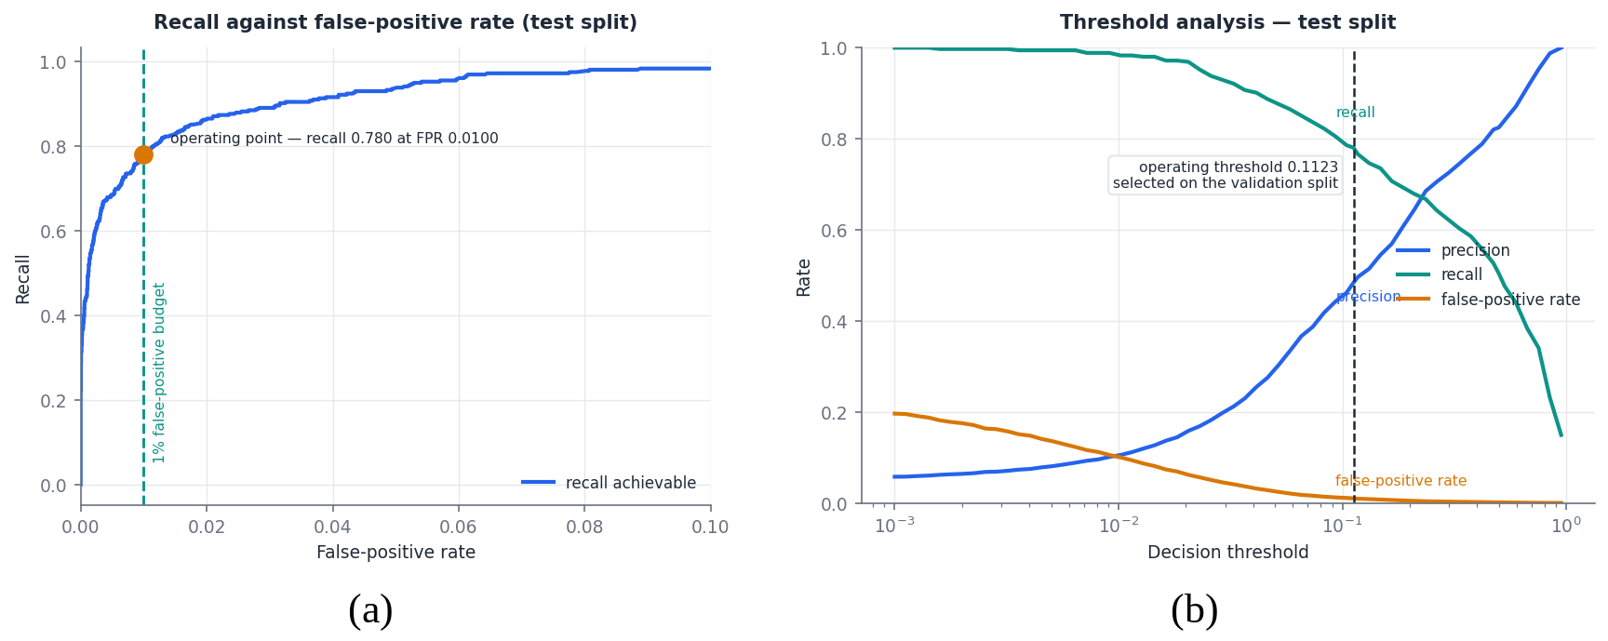
Fig. 7. Frozen V2 model on the held-out test split: (a) recall against false-positive rate, with the dashed line marking the 1% budget; (b) precision, recall and FPR as functions of the decision threshold, with the vertical line marking the threshold selected on validation (0.1123).

G. Scenario-Wise Recall
Table VII reports held-out recall by scenario. V2 detects 120 of 182 social-engineering payments (65.93%), 68 of 80 mule-collection payments (85.00%), 69 of 73 account-takeover payments (94.52%) and all 20 card-testing payments (100.00%). Relative to V1, the gains are concentrated in the two scenarios in which the payer’s own behaviour is least informative. Social engineering remains the hardest scenario for both models.
TABLE VII
Scenario-Wise Recall (Held-Out Test Split)
Scenario | Cases | V1 | V2
Social engineering | 182 | 19.23% (35) | 65.93% (120)
Mule collection | 80 | 63.75% (51) | 85.00% (68)
Account takeover | 73 | 94.52% (69) | 94.52% (69)
Card testing | 20 | 100.00% (20) | 100.00% (20)
Legitimate (FPR) | 29,645 | 0.945% (280) | 0.995% (295)

H. Calibration
Fig. 8 shows V2 reliability curves on the held-out test split. With quantile bins, only four bins are populated because most predictions lie near zero, and those bins lie close to the diagonal. Fixed-width bins expose the upper range. The lowest bin (predicted probability below 0.1) contains 29,383 payments, with a mean prediction of 0.0033 and an observed fraud rate of 0.0025. Intermediate bins show observed rates close to, or somewhat above, the mean prediction; for example, the 0.3–0.4 bin (46 payments) has an observed rate of 0.435 against a mean prediction of 0.347. The top bin contains 71 payments, all fraudulent, with a mean prediction of 0.973. The intermediate bins hold between 33 and 231 payments each, so their rates are estimated imprecisely. Both calibrated models improve on the base-rate predictor (BSS 0.525 for V2 and 0.317 for V1). These results describe calibration on the simulator only.
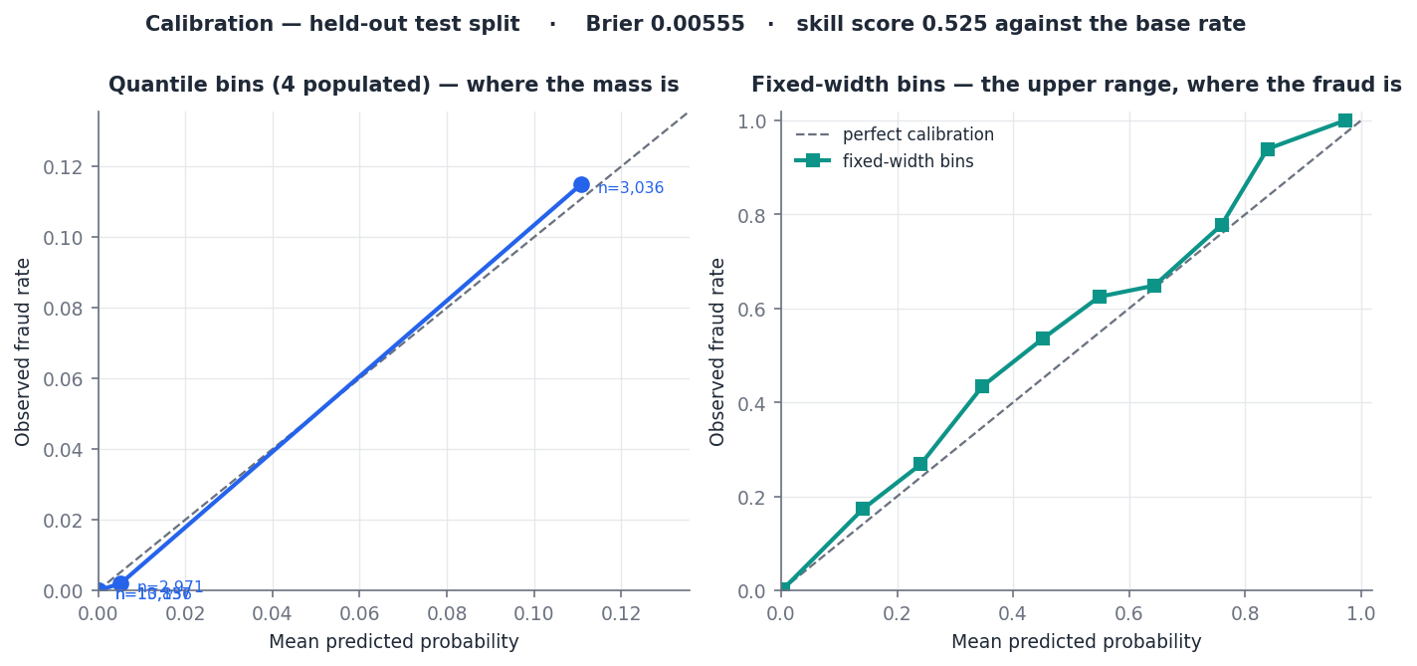
Fig. 8. Calibration of the frozen V2 model on the held-out test split: quantile bins (left) and fixed-width bins (right); Brier score 0.00555, skill score 0.525.

I. Feature Importance and SHAP
Fig. 9(a) shows V2 permutation importance on the test split. The five highest-ranked features are payee_is_new (0.3656), arrival_span_days (0.2455), amount_over_user_avg (0.2059), msg_coercion_probability (0.1379) and component_size (0.1209). They are followed by txns_last_hour (0.1018), days_since_first_payment_to_payee (0.0765), seconds_since_last_txn (0.0732), lifespan_days (0.0587) and txns_today_over_avg (0.0534). Individual message-cue indicators, link features and availability flags score near zero, some slightly negative. Permutation importance indicates predictive usefulness under this protocol, not causal influence, and correlated features can share or trade importance. Fig. 9(b) shows mean absolute SHAP values computed on the uncalibrated first-fold booster over 200 test rows. By this measure payee_is_new again leads, followed by arrival_span_days, amount_over_user_avg and component_size. These magnitudes are on the booster’s raw scale.

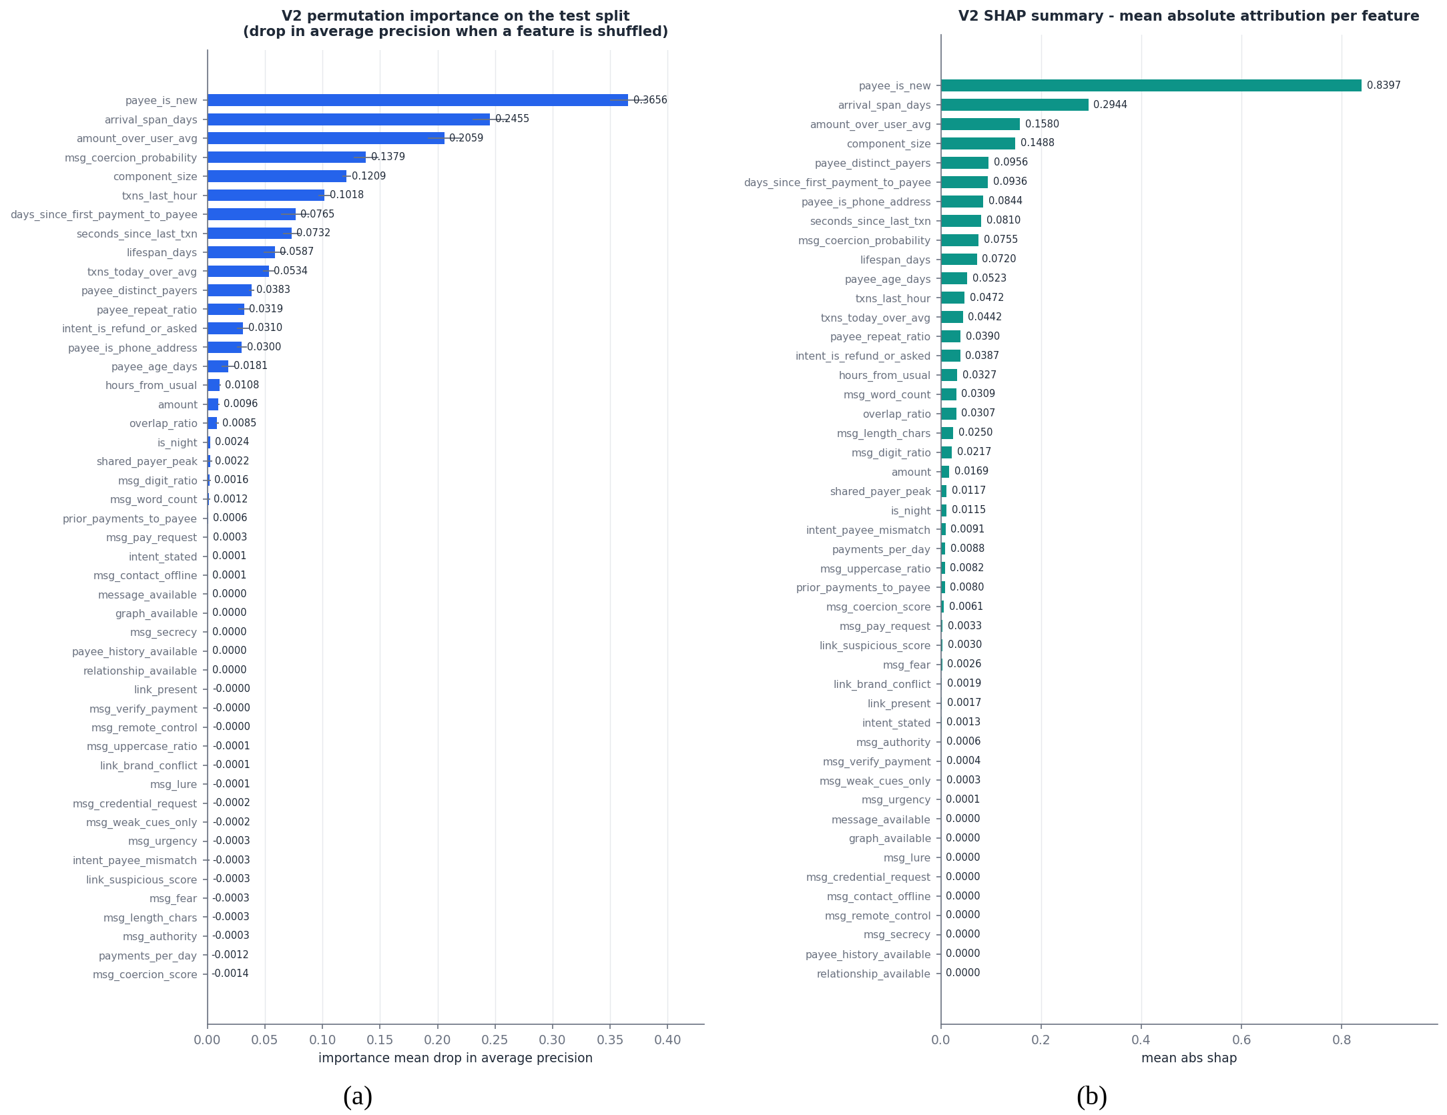
Fig. 9. V2 feature attribution on the held-out test split: (a) permutation importance (mean drop in average precision when a feature is shuffled; five repeats); (b) mean absolute SHAP attribution from a tree explainer on the uncalibrated booster of the first calibration fold (200 rows).

J. Ablation and Model-Family Comparison
Table VIII reports the V2 ablation and model-family comparison. Every model in the table is uncalibrated and separately trained, so its full-V2 gradient-boosting row (PR-AUC 0.7234) differs from the frozen calibrated V2 result (0.7326). The value 0.7234 is not the V2 result. Likewise, the uncalibrated V1-feature reference (0.4996) differs from the served V1 model (0.4860). The table should be read for differences between its own rows:
- adding the simulated graph group to configuration C raises PR-AUC from 0.4562 to 0.5653;
- adding the message, link and intent groups to C raises it to 0.5923;
- removing either group from the full set lowers PR-AUC, to 0.6298 without graph and 0.6101 without message, link and intent;
- removing the message channels reduces social-engineering recall most (to 36.8%), whereas removing the graph group reduces mule-collection recall most (to 60.0%).
Configuration C has twelve features but is not V1: it includes the phone-address flag and omits payee_is_new. Among model families on the full V2 features, gradient boosting (0.7234) exceeds the random forest (0.6915), extremely randomised trees (0.5145) and logistic regression (0.5055). These are single fits without significance tests.

TABLE VIII
V2 Ablation and Model-Family Comparison (Held-Out Test Split; Uncalibrated, Separately Trained Models; Threshold From Validation; Not Comparable in Absolute Terms With Table V)
Configuration | Features | PR-AUC | Recall | FPR | SE recall | MC recall
A. Payer timing + amount | 4 | 0.0970 | 0.163 | 0.0093 | 1.6% | 2.5%
B. A + payee | 9 | 0.3156 | 0.377 | 0.0096 | 17.6% | 57.5%
C. B + velocity | 12 | 0.4562 | 0.468 | 0.0096 | 17.0% | 61.3%
D. C + graph | 19 | 0.5653 | 0.546 | 0.0076 | 28.0% | 70.0%
E. C + message, link, intent | 36 | 0.5923 | 0.625 | 0.0106 | 47.8% | 60.0%
F. Full V2, gradient boosting | 47 | 0.7234 | 0.766 | 0.0083 | 65.9% | 78.8%
Full V2 without graph | 40 | 0.6298 | 0.682 | 0.0104 | 57.1% | 60.0%
Full V2 without message, link, intent | 23 | 0.6101 | 0.620 | 0.0092 | 36.8% | 78.8%
V1 twelve features (reference) | 12 | 0.4996 | 0.496 | 0.0093 | 19.2% | 63.8%
Full V2, random forest | 47 | 0.6915 | 0.744 | 0.0104 | 60.4% | 77.5%
Full V2, extremely randomised trees | 47 | 0.5145 | 0.561 | 0.0099 | 49.5% | 38.8%
Full V2, logistic regression | 47 | 0.5055 | 0.566 | 0.0103 | 48.9% | 37.5%

K. Missing-History Analysis
The observation mask hides payee history on 29,376 of 120,000 rows (24.48%). The simulated prevalence is 1.729% among hidden-history rows and 1.005% among visible-history rows. The subsets therefore differ in simulated class distribution because of a masking rule that ties visibility to payer count, and this does not show that missing history causes or indicates fraud. Even among hidden-history rows, 98.3% of payments are legitimate. Missingness can influence the learned probability because payee_history_available is a classifier input, yet its V2 permutation importance is 0.0000 (Fig. 9(a)). The artefacts do not report detection performance separately for the two subsets.

L. Software Validation
Table IX summarises the software validation. These are software test results: they verify implementation properties of the running code and are not measures of predictive accuracy. All 91 test cases in the five modules passed on the evaluated code base.
TABLE IX
Software Validation Results (Running Code; Not Predictive Metrics)
Module | Cases | Main properties verified
Graph cache | 21 | Incremental updates, merge, rollback, concurrency; checks write nothing and never rebuild; bounded query count
Graph semantics | 18 | Merchant/household overlap not evidence; component size never a finding; unknown payee unavailable, not zero
Evidence availability | 15 | No population constants; measured zero ≠ unavailable; availability not a label proxy
Evidence model | 18 | Unavailable evidence has no score or vote; monotonic damped combination; one vote per family
V2 dataset | 19 | V1 columns, labels and order bit-identical; deterministic generation; fan-in gate respected
Total | 91 | All passed

XI. Discussion

A. V1 as the Baseline
The V1 results separate cleanly by scenario, reflecting the information V1 contains. Seven of its twelve features describe the payer, so account takeover and card testing, which depart from the payer’s usual behaviour, are detected at high rates. In social engineering the payer acts at an ordinary time and pace. V1’s only view of the payee is its age, payer count and repeat ratio, which are unavailable for about a quarter of payments, plus payer-relative novelty. The ablation shows that payer and payee features are complementary for this scenario (+7.7 pp over the stronger half), but a social-engineering recall of 19.23% also shows that the V1 representation is insufficient for it.

B. Why V2 Improves over V1 in the Simulation
V2 adds relational, graph, message, link and stated-purpose channels, and under the synthetic protocol it raises PR-AUC from 0.4860 to 0.7326. Social-engineering recall rises from 19.23% to 65.93%, and mule-collection recall from 63.75% to 85.00%, at the cost of 15 additional false positives. The improvement is consistent with the broader representation capturing additional simulated contextual signals, and the feature rankings agree with the ablation. Payee novelty remains the most useful input. Arrival span and component size (both simulated graph features) and the message-coercion probability also rank among the most useful inputs. The ablation attributes social-engineering gains mainly to the message channels and mule-collection gains mainly to the graph channels.
Two properties of the simulator limit how far these observations can be read. First, the scenario-conditional probabilities for the context channels and the graph-feature distributions were set by the designers, and whether real scam payments differ from legitimate ones in the same direction and degree has not been measured. Second, one message feature comes from a coercion model fitted on the same templates from which V2 draws. The size of the V1-to-V2 gain is therefore not an estimate of real-world gain. What the experiment supports more robustly is a property of the learning setup: a calibrated classical learner can use a heterogeneous representation in which whole groups are often missing, with explicit availability indicators, without missingness dominating. The availability flags have near-zero importance in Fig. 9(a).

C. Graph-Derived Evidence
The graph is intended to provide evidence that is invisible from one payer’s history: how many distinct people pay an address, whether they return, how quickly they arrived, and whether they also pay another address with the same pattern. Two separate things have been shown. The predictive experiments show that graph-derived feature channels contribute under a controlled simulation, and the software tests show that the incremental implementation maintains its aggregates correctly without modification or rebuild during checks. What has not been shown is that the running graph, populated by real confirmations and statements, produces the feature distributions the simulator assumes, or that its positional finding identifies collection accounts at any particular rate.

D. Missing Evidence and New Payees
Representing absent payee history explicitly avoids the most dangerous default for this problem, which is describing an unknown address as established. It also avoids the opposite error of warning on every first payment to a stranger; even among hidden-history rows in this corpus, 98.3% of payments are legitimate. The implementation separates a never-observed address, which receives a 6-point finding below the WARN threshold, from an unavailable family, which contributes no rule-based score. Within the classifier, availability is a learned input, and the higher simulated prevalence among hidden-history rows is a property of the masking rule, not an empirical finding about real data.

E. Calibration, Operating Point and Alert Burden
At the 1% FPR budget, V2 raises 572 alerts per 30,000 test payments (an alert rate of 1.9%), and slightly more than half of them (295) concern legitimate payments. Balanced weighting shifts attention toward the rare class, and isotonic calibration restores the observed probability scale, but neither changes the dependence of precision on prevalence. At a lower real prevalence, the same FPR would produce a larger share of false alerts. Accuracy exceeds 98% for both models only because legitimate payments dominate, so it is uninformative here. In the full architecture the classifier is one bounded input, and how aggregation changes the alert burden relative to the classifier alone was not measured.

F. Risk, Confidence and Verdicts
Reporting risk and coverage separately prevents a low score caused by missing evidence from resembling a low score caused by reassuring evidence. High coverage does not mean that a payment is safe, and low coverage does not mean that it is risky. The verdicts are advisory states, and the band boundaries are fixed design parameters that this study did not tune or evaluate on labelled verdict data.

G. Explainability
Evidence findings tied to named facts are the primary user-facing reasons, because they refer to observations that a payer can check. SHAP attributions, available through the explanation interface for V1 and computed offline for V2, describe how the classifier uses its inputs; the offline values explain the uncalibrated booster. Neither form of explanation establishes that a payment is fraudulent or implies causality.

H. Relation to Prior Work
The comparison in Table I is qualitative, because the datasets and tasks are incompatible. Transaction-level models [3] assess transactions from the account holder’s history, and the V1 results illustrate their limitation for payer-authorised fraud. Spade+ [5] maintains dense-subgraph detection incrementally over a large industrial graph, PGLTSE [7] learns temporal graph representations with GNNs, and APGNN [11] learns fine-grained behaviour prototypes. Each of these methods targets detection over a graph, whereas the present study targets an explainable advisory assessment of one payment before submission. The proposed system combines an incremental payer–payee graph with explicit features, a classical calibrated classifier and rule-based evidence aggregation. It is not a GNN. It does not claim that explicit features match learned representations, but trades expressiveness for per-finding interpretability and bounded per-request cost on a small, partially observed graph. Secure UPI [8] motivates the domain but reports accuracy, which is not comparable with the imbalance-aware measures used here.

XII. Threats to Validity and Limitations

A. Synthetic Data
No real UPI transaction data and no private UPI fraud corpus were used. All predictive results come from a simulator whose populations, scenarios and overlaps were specified by the authors. The prevalence of 1.183% and the scenario mixture are experimental settings rather than estimates of real UPI fraud. Precision and PR-AUC depend on prevalence. The simulator also encodes the designers’ beliefs about which features distinguish fraud, and an evaluation drawn from the same simulator cannot reveal where those beliefs are wrong.

B. Simulator-Controlled V2 Channels and Template Overlap
The V2 graph, message, link, intent and relationship channels are generated by the simulator. The coercion model behind one message feature was trained on the same 1,022-message templated pool from which V2 draws its messages, and that pool was written for the project rather than collected from real scam traffic. The message-channel results therefore do not show generalisation to unseen, real-world scam language.

C. Graph Cache Not Used in the Predictive Experiment
The incremental graph cache is not executed in the V2 predictive experiment, because the corpus contains independent rows without payee identities or chronology. The graph-channel results describe simulated graph-derived features; the implementation is validated only by software tests, and the rule-based positional finding was not evaluated on labelled data.

D. No End-to-End Evaluation
The complete ten-family aggregation and verdict system was not evaluated end to end as a predictive benchmark. The predictive results cover one family, the classifier. The rule-based families, aggregation, corroboration and verdict bands were validated for correctness but not for detection performance, so the verdict distribution for fraudulent and legitimate payments is not established.

E. Temporal Replay and V1 Encoding
The pre-payment boundary is enforced structurally in the live path. However, aggregates and the graph are not time-indexed, so replaying historical payments against a store that already contains later payments does not reproduce the pre-payment state. In the offline corpus the boundary holds by construction, so the offline experiments do not test the live path’s temporal handling. Separately, V1 records hours_from_usual as 0 when the usual hour is unavailable, which conflates an unmeasured deviation with a measured zero deviation. V2 inherits this encoding, and its effect was not isolated.

F. Provider Verification Not Configured
The prototype has no NPCI, bank or PSP integration. The optional provider-verification interface was not configured, so no real-time external verification occurs and no experimental payee is VERIFIED.

G. Distribution Shift and Calibration
Real transaction behaviour, scam language, merchant populations, VPA patterns, graph structure, observation coverage and fraud prevalence may differ substantially from the simulator, and fraud adapts over time [3]. The isotonic calibrators were fitted on roughly 170 fraudulent examples per training fold, and calibration may change under real-world prevalence. All results come from one seed and one split.

H. Security and Deployment
Four issues remain in the current prototype code:
- The graph endpoint (/fraud-graph) returns stored payer–payee edges, and thus other users’ payment relationships, to any authenticated caller.
- The health endpoint (/health) is unauthenticated and reports library versions.
- The assistant endpoint (/chat) can return provider error text in a diagnostic field.
- Payee reports (/payee/report) are counted by distinct reporter but are not rate-limited.
An advisory layer is also an attack surface, since verdicts can be probed and reports or confirmations used to shape evidence. These issues must be resolved before any deployment beyond a controlled prototype.

I. Repository Reproducibility State
At the time of writing, the evaluated working tree contained 81 uncommitted changes, and the time-normalisation module clock.py was untracked. The script evaluate_model_v2.py did not match the hash recorded in its manifest. The principal model and data artefacts do match their recorded hashes: both model files, both metrics files, the dataset generators and feature modules, the training script, the message corpus and the coercion weights. A module named temporal_gnn.py implements an hour-of-day histogram and is not a graph neural network. A tagged commit is required before the code accompanies this paper.

J. Scope of Claims
The system has not been deployed in production, and nothing in this paper is a measurement of production performance. The simulator provides reproducibility and control at the cost of ecological validity.

XIII. Conclusion and Future Work
This study examined whether a pre-payment assessment for UPI-style payments can combine payer behaviour, observed payee history, relational structure and payment context while remaining explicit about what it does not know. The proposed architecture shows that this combination is feasible within a single advisory assessment. Ten evidence families declare their availability and the typed facts they rely on, and an incremental payer–payee graph supplies explicit relational quantities without per-request rebuilding. A damped-maximum rule with fact-aware corroboration keeps one observation from being counted several times, risk and coverage are reported separately, and every rule-based contribution to risk is a named finding. Several of these properties hold by construction and are checked by software tests rather than by the simulator.
The predictive experiments evaluate the classifier component under controlled synthetic conditions. The V1 baseline retained by the prototype reaches a held-out PR-AUC of 0.4860 but detects only 19.23% of social-engineering payments. The expanded V2 research representation, frozen and evaluated offline, reaches a PR-AUC of 0.7326 and a recall of 0.7803 at an FPR of 0.00995, with well-calibrated probabilities on the simulator. Payee novelty, arrival timing and message coercion are among its most useful inputs. The direction of this result supports the premise that payee-side, relational and contextual evidence matters for payer-authorised fraud. Its magnitude does not transfer to real payments, because the added channels were generated by the same simulator and the message features overlap with their training templates.
Future work should address these limitations directly:
- evaluation on independent real-world transaction data and on externally validated, multilingual scam-message corpora;
- end-to-end evaluation of the incremental graph and the complete ten-family verdict system through chronological replay with time-indexed aggregates;
- tests on held-out, unseen scam patterns;
- independent calibration assessment at realistic prevalence with repeated runs;
- deployment-scale latency measurement;
- privacy-preserving validation with financial institutions;
- learned graph representations, only if real graph data show explicit features to be insufficient;
- provider integration, only after appropriate security review, authorisation, and resolution of the issues in Section XII-H.
None of these extensions is implemented in the present prototype.

References
[1] S. Rastogi, C. Panse, A. Sharma, and V. M. Bhimavarapu, “Unified Payment Interface (UPI): A digital innovation and its impact on financial inclusion and economic development,” Universal J. Accounting Finance, vol. 9, no. 3, pp. 518–530, 2021, doi: 10.13189/ujaf.2021.090326.
[2] R. J. Bolton and D. J. Hand, “Statistical fraud detection: A review,” Statist. Sci., vol. 17, no. 3, pp. 235–255, 2002, doi: 10.1214/ss/1042727940.
[3] A. Dal Pozzolo, G. Boracchi, O. Caelen, C. Alippi, and G. Bontempi, “Credit card fraud detection: A realistic modeling and a novel learning strategy,” IEEE Trans. Neural Netw. Learn. Syst., vol. 29, no. 8, pp. 3784–3797, Aug. 2018, doi: 10.1109/TNNLS.2017.2736643.
[4] J. Braithwaite, “‘Authorized push payment’ bank fraud: What does an effective regulatory response look like?,” J. Financial Regulation, vol. 10, no. 2, pp. 174–193, 2024, doi: 10.1093/jfr/fjae006.
[5] J. Jiang, Y. Chen, B. He, M. Chen, and J. Chen, “Spade+: A generic real-time fraud detection framework on dynamic graphs,” IEEE Trans. Knowl. Data Eng., vol. 36, no. 11, pp. 7058–7073, Nov. 2024, doi: 10.1109/TKDE.2024.3394155.
[6] B. Hooi, H. A. Song, A. Beutel, N. Shah, K. Shin, and C. Faloutsos, “FRAUDAR: Bounding graph fraud in the face of camouflage,” in Proc. 22nd ACM SIGKDD Int. Conf. Knowl. Discovery Data Mining, 2016, pp. 895–904, doi: 10.1145/2939672.2939747.
[7] J. Ma, S. Xiang, Q. Li, L. Yuan, D. Cheng, and C. Jiang, “Parallel graph learning with temporal stamp encoding for fraudulent transactions detections,” IEEE Trans. Big Data, vol. 11, no. 4, pp. 1945–1958, 2025, doi: 10.1109/TBDATA.2024.3499338.
[8] R. Rani, A. Alam, and A. Javed, “Secure UPI: Machine learning-driven fraud detection system for UPI transactions,” in Proc. 2nd Int. Conf. Disruptive Technol. (ICDT), 2024, pp. 924–928, doi: 10.1109/ICDT61202.2024.10489682.
[9] Y. Dou, Z. Liu, L. Sun, Y. Deng, H. Peng, and P. S. Yu, “Enhancing graph neural network-based fraud detectors against camouflaged fraudsters,” in Proc. 29th ACM Int. Conf. Inf. Knowl. Manage. (CIKM), 2020, pp. 315–324, doi: 10.1145/3340531.3411903.
[10] M. Weber, G. Domeniconi, J. Chen, D. K. I. Weidele, C. Bellei, T. Robinson, and C. E. Leiserson, “Anti-money laundering in Bitcoin: Experimenting with graph convolutional networks for financial forensics,” arXiv:1908.02591, 2019.
[11] X. Wang, H. Yu, J. Guo, P. Li, and X. Luo, “Towards fraud detection via fine-grained classification of user behavior,” IEEE Trans. Big Data, vol. 11, no. 4, pp. 1994–2007, 2025, doi: 10.1109/TBDATA.2024.3517313.
[12] T. Saito and M. Rehmsmeier, “The precision-recall plot is more informative than the ROC plot when evaluating binary classifiers on imbalanced datasets,” PLoS ONE, vol. 10, no. 3, Art. no. e0118432, 2015, doi: 10.1371/journal.pone.0118432.
[13] J. Davis and M. Goadrich, “The relationship between precision-recall and ROC curves,” in Proc. 23rd Int. Conf. Mach. Learn. (ICML), 2006, pp. 233–240, doi: 10.1145/1143844.1143874.
[14] A. Niculescu-Mizil and R. Caruana, “Predicting good probabilities with supervised learning,” in Proc. 22nd Int. Conf. Mach. Learn. (ICML), 2005, pp. 625–632, doi: 10.1145/1102351.1102430.
[15] B. Zadrozny and C. Elkan, “Transforming classifier scores into accurate multiclass probability estimates,” in Proc. 8th ACM SIGKDD Int. Conf. Knowl. Discovery Data Mining, 2002, pp. 694–699, doi: 10.1145/775047.775151.
[16] G. W. Brier, “Verification of forecasts expressed in terms of probability,” Monthly Weather Rev., vol. 78, no. 1, pp. 1–3, 1950.
[17] J. H. Friedman, “Greedy function approximation: A gradient boosting machine,” Ann. Statist., vol. 29, no. 5, pp. 1189–1232, 2001, doi: 10.1214/aos/1013203451.
[18] E. A. Lopez-Rojas, A. Elmir, and S. Axelsson, “PaySim: A financial mobile money simulator for fraud detection,” in Proc. Eur. Model. Simul. Symp. (EMSS), 2016, pp. 249–255.
[19] N. V. Chawla, K. W. Bowyer, L. O. Hall, and W. P. Kegelmeyer, “SMOTE: Synthetic minority over-sampling technique,” J. Artif. Intell. Res., vol. 16, pp. 321–357, 2002, doi: 10.1613/jair.953.
[20] G. Ke, Q. Meng, T. Finley, T. Wang, W. Chen, W. Ma, Q. Ye, and T.-Y. Liu, “LightGBM: A highly efficient gradient boosting decision tree,” in Proc. Adv. Neural Inf. Process. Syst. (NIPS), vol. 30, 2017, pp. 3146–3154.
[21] S. M. Lundberg and S.-I. Lee, “A unified approach to interpreting model predictions,” in Proc. Adv. Neural Inf. Process. Syst. (NIPS), vol. 30, 2017, pp. 4765–4774.
[22] F. Pedregosa et al., “Scikit-learn: Machine learning in Python,” J. Mach. Learn. Res., vol. 12, pp. 2825–2830, 2011.
[23] L. Breiman, “Random forests,” Mach. Learn., vol. 45, no. 1, pp. 5–32, 2001, doi: 10.1023/A:1010933404324.

